

Operations
and
Safeguarding
Handbook
2026



Operations & Safeguarding Handbook (OSH)

CONTENTS

Introduction 1
Mission, Vision & Values Statement 2
Safeguarding And Child Protection Statement: 3
Diversity, Equity And Inclusion 4
Enrolment 5
Behaviour 8
Special Educational Needs 9
Student Attendance 9
Child Protection 10
Prevent 15
Supervision 16
Safety 17
Centre Management And Responsibility 18
Internet And Technology Safety 18
Artificial Intelligence (AI)
First Aid 19
Incidents 19
Accidents 20
Medication And Allergies 20
Health 21
Infectious Diseases 22
Fire Safety 23
Fire Action 23
Visitors 24
Missing Persons 24
Suspected Intruder/Lock Down 25
Transport 26
Excursions 27
Major Serious Incident 27
Act Of Terror 28
Expenses / Petty Cash 29
Budget 29
Records 29
Complaints Procedure 30
Confidentiality 30

APPENDICES 31
Appendix 1 - Terms And Conditions 31
Appendix 2 – Group Declaration Form 34
Appendix 3 - Statement Of Consent 35
Appendix 4 – Enrolment Form For Individuals (UKLC) 36
Appendix 5 – UKLC Enrolment Form / WASP Enrolment Form 38
Appendix 6 - Code Of Conduct For Students 41
Appendix 7 - Code Of Conduct For Adults 41
Appendix 8 – Lado And Prevent Contact Details Per Centre 43
Appendix 9 – Concern/ Allegation Form 44
Appendix 10 – Prevent Form 46
Appendix 11 - Centre Residential Group Checklist 50
Appendix 12 – First Aid Usage Form 51
Appendix 13 – Incident Form 52
Appendix 14 – Accident Form 55
Appendix 15 - Fire Log Form 59
Appendix 16 - Visitors Log 60
Appendix 17 - UKLC Team Excursion Information Sheet 62
Appendix 18 - Complaints Form 65
Appendix 19 - Recruitment Policy 66
Appendix 20 - Wycombe Abbey Summer Programmes Booking Form…………………………………………69
Appendix 21 - Wycombe Abbey Summer Programmes Confirmation Letter………………………………….70
Appendix 22 - Anti-Harassment and Bullying Policy………………………………………………….…………….71
Appendix 23 - Sexual Harassment Policy………………….…………………………………………………………..72

Updates .76

INTRODUCTION
This document details the Operations and Safeguarding policies and procedures of UKLC (UK Language Courses Ltd).

Safeguarding young people is fundamental to the way our organisation operates. Our priority is always to ensure the well-being of our students, group leaders, visitors and our team.

As a provider of language courses for under 18s that include their full board accommodation, we should be ensuring that our students remain safe at all times. This is our focus from the moment they arrive to the moment they leave and includes: all transport, scheduled activities, time outside scheduled activities, excursions and time spent in their homestay or residential accommodation.

We have a ‘whole school’ approach to safeguarding wherein the team should respond to all signs, reports and concerns of abuse and are advised to maintain an attitude that ‘It could happen here’.

These are the measures we take to ensure the safety of our students, group leaders, UKLC teams and visitors at all times and ensure that good practice is followed.

This document (or parts thereof) is available for any agent/Educational Travel Operator (ETO), group leader, student, parent, individual, employee, supplier or potential client of UKLC to read and be reassured by.

All persons working for UKLC must read this document. Every team member must sign to say this document has been read, and that they have understood and agreed to abide by these policies and procedures. Sessional team members will be made aware of this document and will have access to it; they will be advised and supported by the UKLC full time and senior leadership teams.

Our procedures are detailed in the following documents:
- Operations and Safeguarding Handbook (this document – also available in condensed and super condensed format),
- Culture Book for Employees and Employee Handbook,
- Risk Assessments,
- Team Handbooks,
- Privacy Policy (hosted on UKLC website).

This document was regularly revisited between March 2020 and July 2022 and amended in light of the Covid-19 pandemic. At UKLC our priority is always the safety and wellbeing of our students and team. As we now operate in a post Covid world, we are keen to offer reassurance to agents/ETOs, parents and students about how we will operate and reduce risks as much as we can. Please see our Infectious diseases policy for more information.

MISSION, VISION & VALUES STATEMENT

UKLC Mission:
Educate, Inspire, Enrich
To educate, to inspire and to enrich the lives of young people from all over the world through English language, sports and British culture.

UKLC Vision:
By 2025 we will have built upon our reputation for delivering top quality programmes that educate, inspire and enrich at desirable locations across the UK and be known for offering true educational and cultural benefit across a variety of summer and year-round programmes. Our dynamic team, operational excellence, innovative approach and responsive service will ensure the loyalty of our partners and place us as the top language provider for young people in the UK.

UKLC Values:
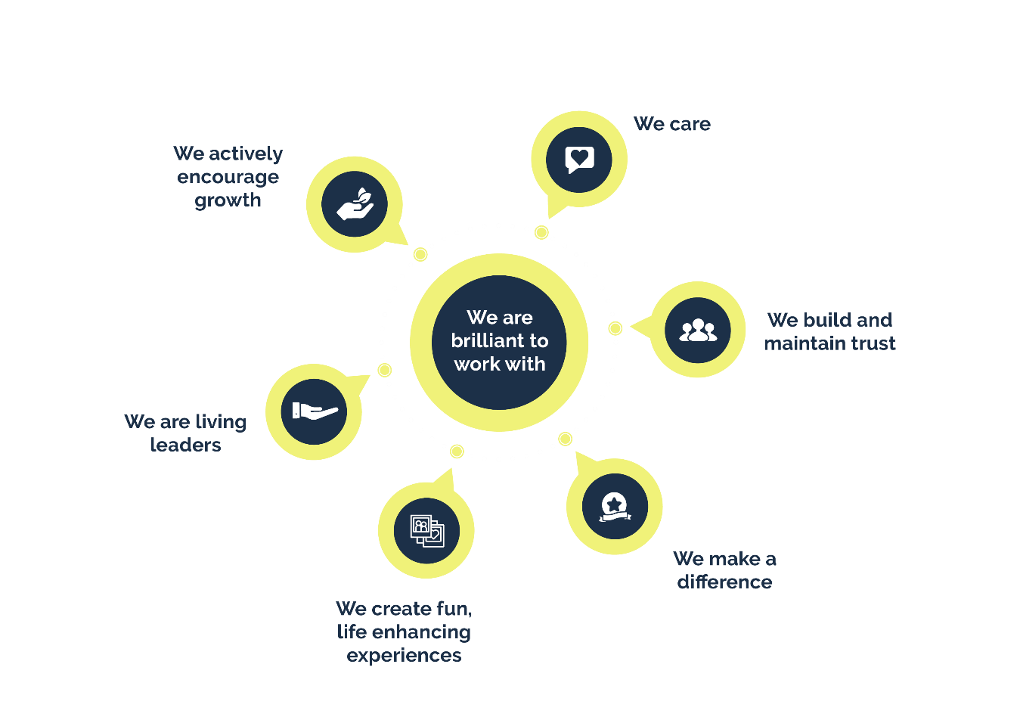

UKLC co-ordinate and deliver a number of residential and homestay courses for specific agents/ETOs, groups and schools. The age range of students is usually but not always between 8 and 17 years of age. UKLC operate from a number of sites throughout the UK.

SAFEGUARDING AND CHILD PROTECTION STATEMENT:
UKLC is committed to providing a safe and secure environment for the young people in our care.

The way we ensure this is by:
- Operating a rigorous recruitment process and thoroughly vetting all applicants (see APPENDIX 19 - Recruitment Policy).
- Having a clear Safeguarding Policy (this document) and clear procedures for protecting the students in our care and keeping them safe.
- Having a clear Child Protection Policy and clear procedures for its implementation.
- Ensuring that all members of our team, accompanying group leaders and subcontractors (e.g. homestay providers) are aware of and conversant with the relevant areas of our Safeguarding Policy, that all team members are trained in it (see induction procedures) and that all team members are invited to complete an online Safeguarding in Language Centres course and submit the certificate to head office. We also ensure that all team members and group leaders agree to adhere to the Code of Conduct for Adults (APPENDIX 7) APPENDIX 7 - Code of Conduct for Adults
- Having an awareness of all mental health issues that the young people in our care could face and ensuring that all management teams complete an online Child Mental Health Awareness training.
- Having a clear Behaviour Policy in place and procedures to ensure that our centres are free from discrimination, racism, bullying, harassment and extremism (see Behaviour Policy).
- Having a Diversity, Equity and Inclusion policy that helps us to foster an environment of mutual trust, respect and understanding whether it be with the people we employ, the companies and countries we work with or the students we host (page 6)
- Having Anti-Bullying and Harassment and Sexual harassment policies to ensure our centres are free from bullying and sexual harassment and ensuring all employees are treated, and treat others, with dignity and respect (see APPENDIX 22 Anti-Bullying and Harassment Policy and APPENDIX 23 Sexual Harassment)
- Reviewing and updating all policies in this document on a regular basis and responding to feedback and suggestions from all areas of the business.

Explanation of terms:
For those not familiar with the terms used, we understand “Safeguarding” to mean “looking after” and use it as the “umbrella” term that incorporates everything we do to “look after” the young people in our care.

We understand that the definition of Safeguarding now includes mental health, and we are committed to supporting and promoting good mental health amongst our team, students and group leaders.

We understand Child Protection to mean protecting young people from direct harmful behaviour.

This document and the policies detailed within are relevant for all the young people within our care regardless of race, gender, ethnic origin or religion. We believe that all young people have the right to be protected.

Roles and responsibilities:
In every centre where there are over 75 students, we will have two Designated Safeguarding Persons (DSPs – our DSPs act as our Prevent Leads). One will be the Centre Manager and the other the Safeguarding and Welfare Co-ordinator. These persons have a responsibility to read and assimilate all areas of this document and ensure that all adults and students adhere to it. In smaller centres under 75 students, the Centre Manager will act as the DSP.

All adults connected to UKLC (team members, group leaders, subcontractors) have a responsibility to read all relevant areas of this document and show an awareness at all times of the need to safeguard students in our care.

All students will be made aware (through their Welcome Talk) of the existence of our policy and our commitment to keeping them safe. They will be asked to look out for each other and raise concerns with an adult where necessary.

In our head office team, our overall Designated Safeguarding Lead is our Operations Director, Jamie Brailsford. He is supported by our Head of People and Culture, Carolyn Rennoldson and our Head of Operations, Jordan Dallimore. They share overall responsibility for Safeguarding, Child Protection and Prevent.

Explanation of UKLC programmes:
- UKLC predominantly deliver language programmes, including accommodation, activities, sports and excursions for under 18s in homestay and residential accommodation. These occur mainly during July and August, but Mini-stay (shorter) programmes are also offered between September and June.
- UKLC offer pastoral care and activity programmes at several boarding schools around the UK where students are able to stay in their year-round accommodation and participate in a programme of activities and excursions. These are called our “Rest & Re-energise” programmes. Removal of “Rest & Re-energise2 but still show pastoral care at boarding schools? (Prior Park model) ??
- UKLC at Wycombe Abbey is a specialised programme for small groups and individuals that is delivered at Wycombe Abbey School in the summer.
Our operating policies and procedures detailed in this document cover all these different programmes and where there is a difference, it is stated.

DIVERSITY, EQUITY AND INCLUSION
We are committed to promoting equal opportunities in and creating a culture in which diversity and inclusion are valued and everyone is treated with dignity and respect. As part of our zero-tolerance approach to discrimination in any form, everyone will receive equal treatment regardless of age, disability, gender reassignment, marital or civil partner status, pregnancy or maternity, race, colour, nationality, ethnic or national origin, religion or belief, sex or sexual orientation (Protected Characteristics). We are also committed to providing equitable treatment to all those we deal with as an organisation, including customers and suppliers.
Our aim is to encourage and support diversity, equity and inclusion and actively promote a culture that values difference and eliminates discrimination in our head office and our centres. It applies to all aspects of working with us whether at head office or on location at one of our centres and it applies to all our team members, group leaders, students and visitors.
We do not accept unlawful discrimination against or harassment of other people, including current and former team members, job applicants, clients, customers, suppliers, students, group leaders and visitors.
Our full Diversity, equity and inclusion policy can be requested at any time from head office, but here are the examples of that which we find unacceptable and unlawful:
- Direct discrimination: treating someone less favourably because of a Protected Characteristic,
- Indirect discrimination: a provision, criterion or practice that applies to everyone but adversely affects people with a particular Protected Characteristic more than others, and is not justified,
- Harassment: this includes sexual harassment and other unwanted conduct related to a Protected Characteristic, which has the purpose or effect of violating someone's dignity or creating an intimidating, hostile, degrading, humiliating or offensive environment for them. Harassment is dealt with further in our Anti-harassment and Bullying Policy,
- Victimisation: retaliation against someone who has complained or has supported someone else's complaint about discrimination or harassment. This includes where someone mistakenly believes that the person victimised has done so.
- Disability discrimination: this includes direct and indirect discrimination, any unjustified less favourable treatment because of the effects of a disability, and failure to make reasonable adjustments to alleviate disadvantages caused by a disability.

Breaches of this policy
We take a strict approach to breaches of this policy, which will be dealt with in accordance with our Disciplinary Procedure for team members and through our behaviour policy for students. Serious cases of deliberate discrimination and victimisation may amount to gross misconduct resulting in dismissal or ejection from one of our programmes.
If you believe that you have suffered harassment, bullying or discrimination, or witnessed it happening to someone else at head office or on location at a centre, you can raise the matter using our grievance procedure and through our Anti-harassment and Bullying Policy as appropriate. Complaints will be treated in confidence and investigated as appropriate.
We encourage the reporting of all types of potential discrimination, as this assists us in ensuring that diversity, equity and inclusion principles are adhered to in the workplace. However, making a false allegation in bad faith, or that you know to be untrue, will be treated as misconduct and dealt with under our disciplinary procedure.

ENROLMENT

Policy
Our enrolment policy differs depending on the programme offered.

For UKLC programmes, all our students are booked through agents/ETOs. We accept individuals (at certain centres), and groups accompanied by a group leader.

For the UKLC at Wycombe Abbey programmes, all our students are booked through agent/ETOs. We accept individuals, and small groups accompanied by a group leader, as well as students who book directly through Wycombe Abbey School

For Rest & Re-energise programmes, students will either book via their school

Procedure for UKLC programmes
The following is our formal bookings procedure for UKLC programmes:

- Initial Booking: Following an enquiry, an agent/ETO will reserve an allocation with provisional student and group leader numbers in a specific centre/s for specific dates.
- Formal Quote: The UKLC sales team send a formal quote to confirm:
- Provisional student and group leader numbers
- Price
- Dates
- Centre
- Deposit Invoice: A deposit invoice is then sent out with T&Cs – Terms & Conditions) for 20% of the booking total. The payment of the deposit confirms the booking. The deposit is deducted from the final invoice amount for the group.
- Booking Documents: The UKLC sales team will then start sending documents that need completing and returning at the earliest opportunity. More information about these can be found below.
- Final Invoice: Once the booking is confirmed, a final invoice is sent with final student and group leader numbers and flight transfers added on (if booked). The deposit invoice amount will have been removed from the final amount.
- Pre-arrival Documents: The UKLC sales team send everything the group needs ready for arriving in the UK. Including:
- The Programme
- The Centre Handbook
- Group Leader Handbook
- Operations & Safeguarding Handbook (OSH)
- Group Confirmation Sheet (GCS)
- Arrival in the UK document

More information about these can be found below.

Booking documents:
We require these documents to be filled out and returned at the earliest opportunity.

Group List Template
We require a completed Group List for each group. This form includes information such as student names, allergies and health conditions, emergency contacts details and English Plus options.

This form should be sent regularly with any updates highlighted and not only when the group is closed.

We inform agents/ETOs that we require the English Plus options before 29th May at the latest. If they’re sent after this date, then students will be enrolled onto the multi-activity programme. Any spare places on the English Plus programmes will be offered on arrival at centre. We require a minimum of 10 students across the centre to activate an English Plus Option which is why we request a second choice. The second choice will be defaulted to multi-activity if one is not provided.

If an agent/ETO requires any visa letters for non-EU nationals we also send scanned copies of the visa letters on receipt of this. We request 48 hours to process the form and provide the letters. Visa letters can only be issued on receipt of the deposit which has confirmed the booking.

There is compulsory information required on this form for each student which includes:
- First and surnames,
- Age,
- Gender,
- Nationality,
- Date of birth,
- Arrival and departure dates,
- Parental emergency contact number,
- Agency emergency contact number.

Group Declaration Form
This document includes a section regarding parental consent, confirmation that all students have suitable travel insurance and suitability of group leaders to work with children (APPENDIX 2 – Group Declaration Form). It directs parents to a link on our website where we host the Statement for parents/guardians translated into all the languages of the countries we work with (APPENDIX 3 – Statement of Consent)

Pre-Arrival Documents

The Programme
The updated programme for each group is sent out which includes the excursions and confirms the zig zag programme (if applicable).

Centre Handbook
These are useful tools for agents/ETOs but essential reading for group leaders. They contain information about all aspects of their chosen centre(s).

Group Leader Handbook
This document sets out the expectations for the group leaders including information on the specific roles and responsibilities between UKLC and the group leaders while they are with us. This needs to be passed onto all group leaders.

Operations & Safeguarding Handbook (OSH)
This is for information only and outlines all the policies and procedures we have in place to ensure the safety and wellbeing of students during their stay with us.

Group Confirmation Sheet (GCS)
A summary of everything related to the booking, including transfer confirmation, arrival and departure details, known medical conditions and allergies of students and leaders. The UKLC team will send this to agents/ETOs and ask them to check all of the information and confirm it is correct. It is then passed on to group leaders to travel with. It will act as transfer confirmation for agents/ETOs who need one. Our on-site teams will also have a copy of this document.

Arrival in the UK
An overview of arrival day, including instructions on what to do at the airport and how to contact us if there is a problem.

Notes to our booking procedure:
  - The above stages and relevant communication with the agent/ETO will be recorded in our internal CRM system.
  - Communication is maintained between UKLC and the agent/ETO from the time that an option / allocation (provisional booking) is requested right up until the final booking is confirmed. This is in order to monitor the progression of sales against the option / allocations (provisional bookings) requested. Depending upon the level of sales, decisions may be taken to increase or reduce allocations in conjunction with the agent/ETO. A booking is considered to be confirmed upon receipt of the deposit payment.
  - When the group is finalised, the agent/ETO sends us the details of the students enrolled in that group, preferably on our template. However, the format this information is received in is different for each company. For example, Spanish and French groups like to send their own individual form for each child that gives all of the necessary information, whereas Italian and Chinese groups prefer to send through a list of names for each group and include any important information about each child on the list (including age, gender and any medical information). We ask all agents/ETOs to supply us with emergency 24-hour contact numbers for the parents/guardians of the students and an out of hours emergency 24-hour contact for the agent/ETO.
  - For individual students we ask for an Individual Enrolment form (APPENDIX 4 – Enrolment Form for Individuals UKLC) to be completed and sent to us four weeks prior to arrival.

To double check all the information we have received and to ensure that we have all necessary information on every student and a correct 24-hour telephone number in case of emergencies, we make every student complete an enrolment form (APPENDIX 5 – UKLC Enrolment Form) on their first day. The enrolment form includes name, age, contact details, medical information and a behaviour statement. These forms are checked over and signed by the group leader, cross referenced with the information we have received about the student and then kept in the on-site office for the duration of the student’s stay with UKLC.

Procedure for the Wycombe Abbey Summer Programme
The following is our formal bookings procedure for individuals attending the Wycombe Abbey Summer Programme:

Individuals booking directly with Wycombe Abbey School

- Full course fees for the course, the Wycombe Abbey Summer Programme Terms and Conditions and an online booking form* are found on the Wycombe Abbey Summer Programme website: https://venue.wycombeabbey.com/summer-programme
- Students complete the Wycombe Abbey online booking form via this link and make an online payment for the full course fees. Receipt of payment is automatically sent via Stripe.
- Upon receipt of the completed form and payment, we send a confirmation letter (APPENDIX 21 - Letter of Confirmation), a link to the student information form* and a copy of the centre handbook to the student.
- We consider the course to be booked on assessment of English level (B1) and receipt of full course fees.
*An offline equivalent of these forms is available (APPENDIX 20 - Wycombe Abbey Summer Programme Booking Form for Individuals)

Individuals booking via agent/ETO

- Net or Gross course fees are agreed with specific agent/ETO and an agent/ETO agreement is signed.
- Students complete the Wycombe Abbey booking form via online forms* (APPENDIX 20 - Wycombe Abbey Summer Programme Booking Form for Individuals & Agents), which also includes the Wycombe Abbey Summer Programme Terms and Conditions (T&Cs).
- Wycombe Abbey raises a quote for the student’s full net course fees and deposit invoice for 20% of these fees.
- Upon receipt of the completed form and payment, we send a confirmation letter (APPENDIX 21 Letter of Confirmation), a link to the student information form, and a copy of the centre handbook to the student.
- We consider the course to be booked on assessment of English level (B1) and receipt of deposit payment.
- Full payment is due on 1st May or upon booking for confirmations made after 1st May.
* Agents/ETOs may use their own booking form(s), provided the same mandatory information is collected.

Booking Documents
We ask all our students to complete a Wycombe Abbey Summer Programme booking form at the time of applying to join the course. This can be done online using the online forms (APPENDIX 20 - Wycombe Abbey Summer Programme Booking Form for Individuals & Agents). More information can be found HERE. In addition to the compulsory student personal details, this form also includes questions about elective choices, rooming requests, and parental consent. When agents choose to use their own application forms, we ask parents / guardians to complete a shorter Parental Consent Form (HERE).

Pre-Arrival Documents

Wycombe Abbey Summer Programme Journal
This student-facing document includes information about the centre, the Wycombe Abbey Summer Programme team, courses and excursions, the Code of Conduct, and Ground Rules.

Behaviour Policy
UKLC are committed to fostering an environment where students, group leaders, teachers, the UKLC team and those employed by the centre, can study, work and live free from intimidation, aggression, coercion, racism or victimisation. We are particularly concerned about eliminating all forms of harassment, bullying or behaviour that may lead to extremist* radicalisation and we consider such behaviour unacceptable and discriminatory. These behaviours are considered abusive and will not be tolerated. All students, UKLC team members and group leaders are responsible for helping to ensure that no one suffers in this way and that all equipment, facilities and accommodation are treated with respect.

*Applies to any form of extremism, e.g. terrorism, racism, homophobia or right-wing ideology.

We aim to create a stimulating environment in which students can enjoy their stay, improve their English as much as possible and grow in confidence. We aim to build self-esteem by acknowledging the achievements of individuals and giving praise and recognition whenever possible. We therefore seek to encourage and reward good work, good behaviour and a good attitude.

Procedure
To promote good behaviour UKLC team members will:

- Ensure that all students attend the initial “Welcome Talk” where the expected standard of behaviour is outlined,
- Re-iterate the expected standard of behaviour through the APPENDIX 6 – Code of Conduct for Students - covered in the first lesson, and included in the student journal
- Make their lessons, activities and sessions fun and interesting,
- Praise good behaviour,
- Initially ignore any minor attention-seeking behaviour,
- Act as a role model with a smart, clean appearance, good manners and time keeping,
- Explain why certain behaviour is unacceptable,
- Promote core British values – a. Democracy, b. Rule of Law, c. Individual liberty, d. Respectful tolerance of different faiths or beliefs.

In the case of unacceptable behaviour persisting, UKLC reserve the right to curtail any activity.

All students are required to wear a UKLC wristband and lanyard at ALL times. If a student is found not to be wearing these then UKLC reserve the right to apply a small sanction (e.g. £1 fine) to ensure that students remember to wear them.

We operate a ‘Ground rules’ policy to manage behaviour:

- Talked to: If a student misbehaves, the Centre Manager can give them a first warning. This will take place in a brief meeting with the student and group leader and will be recorded on an incident form.
- Yellow card: If they seriously misbehave again then we organise a telephone call home to their parents and we ask for the group leader’s/agent’s support in this.
- Red card: If this fails to work and the participant continues to misbehave then we will ask them to leave and contact their agent to organise their transport.

Any action will be discussed with group leaders and significant events will be recorded on incident forms.

UKLC team members will not employ the following methods to manage unacceptable behaviour:
- Shouting,
- Use of words such as ‘Shut Up’,
- Criticism and mockery,
- Physical punishments,
- Use of extended periods of ‘time out’ or isolation.

Restraint of a young person will never occur, unless to prevent personal injury to the student, other students, an adult or serious damage to property. Any such incident would always be recorded on the relevant forms.

If a student, group leader, or member of the UKLC team are the victims of, or aware of, any abusive behaviour, they should report it immediately. Students can report such behaviour to any member of the UKLC team or their group leader, who will then in turn report the incident(s) to the Centre Manager / the Safeguarding and Welfare Coordinator and / or the Senior Leadership Team. If the abusive behaviour involves any member of the UKLC team, it should be reported directly to the Centre Manager or the Safeguarding and Welfare Co-ordinator and / or the Senior Leadership Team.

SPECIAL EDUCATIONAL NEEDS

Policy
When special needs are identified, we will endeavour to work in partnership with the students, the agent/ETO, the group leader and other relevant parties to ensure that the student can participate as fully as possible in the programme. UKLC must be informed at the earliest possible opportunity before travel.

Procedure
Support requirements would be discussed, and a support plan recorded, on an individual or group basis. The support plan would include aspects such as special services and equipment, and additional staffing requirements. Should intimate care need to be provided as part of a student’s care, we would accept for a carer to accompany the student, and we would endeavour to offer the facilities necessary for such care. Additional accommodation costs would need to be funded either by the agent/ETO or the parents.

The physical environment of our centres would meet the needs of children with different disabilities, although children with reduced mobility would have difficulties with some of the sites we use. However, we endeavour to ensure that students with special needs have access alongside their peers to the lessons, activities, excursions and facilities provided in order to promote their welfare and development.

STUDENT ATTENDANCE

Policy
All students enrolled at UKLC must attend a minimum of 90% of the lessons, activities and excursions in order to receive their certificate for having completed the course. Absence for any reason other than illness will not normally be accepted.

Procedure
- Attendance registers are taken at the start of every lesson, afternoon activity, evening activity and on excursions.
- Absence from lessons must be reported by the students’ group leader to the Course Director.
- Absence from activities and/or excursions must be reported by the group leader to the Excursion and Activities Manager.
- If a UKLC team member realises that a student has failed to turn up for an organised lesson, activity or excursion and 15 minutes has passed, they should inform the relevant member of the Centre Management Team.
- If a student is absent due to illness for more than three days, they must be attended to by a medical professional and a record of this must be kept.

In the situation where a student is removed by pre-arrangement from our centre by a family member or friend for a short period of time, a written consent must be received with the personal details of who is collecting them and when they are returning. The onsite UKLC team will ask this person for identification before releasing the student to them.

CHILD PROTECTION

Policy
All our students should expect to feel safe both whilst they are staying with UKLC and also in their home life in their own country. We see it as our moral duty and it is a legal requirement for us to respond to any concerns that may come to our attention about the safety of students, whether this be during their stay or in their everyday life.

We are committed to establishing an atmosphere of trust between the students in our care and all adults they come into contact with. To this end all adults coming into contact with students on UKLC courses must adhere to the APPENDIX 7 - Code of Conduct for Adults (APPENDIX 7)

If any member of the UKLC team, any host or any group leader has any doubts about the wellbeing of any young person within their care, it must be reported to one of the Designated Safeguarding Persons at the Centre immediately.

This policy has been drawn up to protect young people from abuse and neglect. It sets out the procedures that must be followed in the event of any allegations of abuse or neglect. The duty of UKLC is to protect a young person from harm, and this comes before the need to maintain confidentiality. The safety of the young person must be of paramount consideration. Team members and hosts are made aware that suspicion of abuse may take the form of concerns rather than known facts. Concerns can and will be shared with the relevant agencies through a referral.

UKLC will ensure that any adult whose role involves responsibility for or substantial access to under-18s understands their duty to follow these procedures.

This is done by:
- Reference to our Operations and Safeguarding Handbook in all materials used for recruitment,
- A copy of our Operations and Safeguarding Handbook to be sent to all prospective employees, sub-contractors and our hosting institutions,
- Team training in the Operations and Safeguarding procedures (online and in person),
- Asking all our hosting institutions to inform us of their recruitment and checking processes for staff who will be on site at the time our courses are running,
- Dissemination of this policy to all our partners and their group leaders. (A further copy is given to group leaders upon arrival and further training is given to them in order to make sure that they fully understand their role and responsibilities).

We use the 5 Rs in order to understand what we need to do if a concern arises:
- Recognise – physical signs/behavioural changes,
- Respond – take action – don't ignore the situation,
- Report – report to the Safeguarding Lead (unless implicated) and share on a need-to-know basis only,
- Record – concerns, disclosures and allegations should be recorded on a Concern Form,
- Refer – situation may need to be reported to statutory authorities (police, children's services, etc.) by Company DSL.

We are aware of what constitutes abuse and neglect and that abuse is a form of maltreatment of a young person under 18 years old. We recognise that somebody may abuse or neglect a young person by inflicting harm or by failing to act to prevent harm. Harm can include ill treatment that is not physical as well as the impact of witnessing ill treatment of others. This can be particularly relevant, for example, in relation to the impact on children of all forms of domestic abuse.

Children may be abused in a family or in an institutional or community setting by those known to them or, more rarely, by others. Abuse can take place wholly online, or technology may be used to facilitate offline abuse. Children may be abused by an adult or adults or by another child or children.

We believe that someone’s action satisfies the harm test when it appears that they may:
- Harm a child,
- Cause a child to be harmed,
- Put a child at risk of harm,
- Attempt to harm a child,
- Incite another to harm a child.

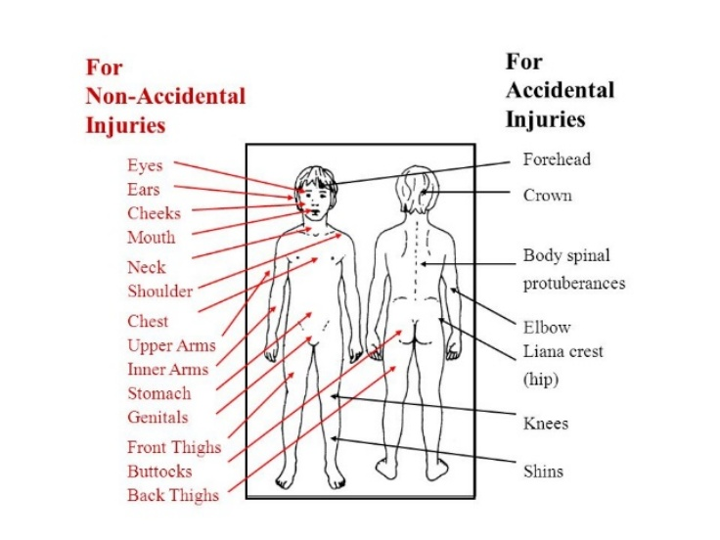
Physical abuse may involve hitting, shaking, throwing, poisoning, burning, scalding, drowning, suffocating or otherwise causing physical harm to a young person. Physical harm may also be caused when a parent or carer feigns the symptoms of, or deliberately causes, ill health to a young person whom they are looking after. Physical abuse may be identified by unexplained or inadequately explained injuries. a form of abuse which may involve fabricating the symptoms of, or deliberately inducing, illness in a child.
Emotional Abuse is the persistent emotional ill treatment of a young person such as to cause severe and persistent adverse effects on the young person’s emotional development. It may involve conveying to a young person that they are worthless or unloved, inadequate or valued only in so far as they meet the needs of another person. Emotional abuse is often from somebody close to the student – such as a parent, relative or guardian. It may include not giving the child opportunities to express their views, deliberately silencing them or ‘making fun’ of what they say or how they communicate. It may feature age or developmentally inappropriate expectations being imposed on children. These may include interactions that are beyond a child’s developmental capability as well as overprotection and limitation of exploration and learning or preventing the child from participating in normal social interaction. It may involve seeing or hearing the ill-treatment of another. It may involve serious bullying (including cyberbullying), causing children frequently to feel frightened or in danger, or the exploitation or corruption of children. Some level of emotional abuse is involved in all types of maltreatment of a child, although it may occur alone.

Sexual abuse involves forcing or enticing a young person to take part in sexual activities, not necessarily involving violence, whether or not the young person is aware of what is happening. The activities may involve physical contact, including assault by penetration (for example rape or oral sex) or non-penetrative acts such as masturbation, kissing, rubbing, and touching outside of clothing. They may also include non-contact activities, such as involving children in looking at, or in the production of, sexual images, watching sexual activities, encouraging children to behave in sexually inappropriate ways, or grooming a child in preparation for abuse. Sexual abuse may be difficult to observe though changes in general behaviour might be an indicator. Usually, this type of abuse emerges through disclosure. Sexual abuse can take place online, and technology can be used to facilitate offline abuse. Sexual abuse is not solely perpetrated by adult males. Women can also commit acts of sexual abuse, as can other children. The sexual abuse of children by other children is a specific safeguarding issue in education and all staff should be aware of it and of their school or college’s policy and procedures for dealing with it.

Neglect persistent failure to meet a child’s basic physical and/or psychological needs, likely to result in serious impairment of the child’s health or development. Neglect may occur during pregnancy, for example, as a result of maternal substance abuse. Once a child is born, neglect may involve a parent or carer failing to: provide adequate food, clothing and shelter (including exclusion from home or abandonment); protect a child from physical and emotional harm or danger; ensure adequate supervision (including the use of inadequate caregivers); or ensure access to appropriate medical care or treatment. It may also include neglect of, or unresponsiveness to, a child’s basic emotional needs.

It is essential that all adults understand the importance of challenging inappropriate behaviours between children, many of which are listed below, that are abusive in nature. Downplaying certain behaviours, for example dismissing sexual harassment as “just banter”, “just having a laugh”, “part of growing up” or “boys being boys” can lead to a culture of unacceptable behaviours, an unsafe environment for children and in worst case scenarios a culture that normalises abuse leading to children accepting it as normal and not coming forward to report it.

Child-on-child abuse is most likely to include, but may not be limited to:
- bullying (including cyberbullying, prejudice-based and discriminatory bullying),
- abuse in intimate personal relationships between children (sometimes known as ‘teenage relationship abuse’),
- physical abuse such as hitting, kicking, shaking, biting, hair pulling, or otherwise causing physical harm (this may include an online element which facilitates, threatens and/or encourages physical abuse),
- sexual violence, such as rape, assault by penetration and sexual assault; (this may include an online element which facilitates, threatens and/or encourages sexual violence),
- sexual harassment, such as sexual comments, remarks, jokes and online sexual harassment, which may be standalone or part of a broader pattern of abuse,
- causing someone to engage in sexual activity without consent, such as forcing someone to strip, touch themselves sexually, or to engage in sexual activity with a third party,
- consensual and non-consensual sharing of nude and semi-nude images and/or videos (also known as sexting or youth produced sexual imagery),
- upskirting, which typically involves taking a picture under a person’s clothing without their permission, with the intention of viewing their genitals or buttocks to obtain sexual gratification, or cause the victim humiliation, distress, or alarm, and,
- initiation/hazing type violence and rituals (this could include activities involving harassment, abuse or humiliation used as a way of initiating a person into a group and may also include an online element).

Child Criminal Exploitation (CCE) Some specific forms of CCE can include children being forced or manipulated into transporting drugs or money through county lines, working in cannabis factories, shoplifting, or pickpocketing. They can also be forced or manipulated into committing vehicle crime or threatening/committing serious violence to others.

Child Sexual Exploitation (CSE) CSE is a form of child sexual abuse. Sexual abuse may involve physical contact, including assault by penetration (for example, rape or oral sex) or nonpenetrative acts such as masturbation, kissing, rubbing, and touching outside clothing. It may include noncontact activities, such as involving children in the production of sexual images, forcing children to look at sexual images or watch sexual activities, encouraging children to behave in sexually inappropriate ways or grooming a child in preparation for abuse including via the internet. CSE can occur over time or be a one-off occurrence and may happen without the child’s immediate knowledge for example through others sharing videos or images of them on social media. CSE can affect any child who has been coerced into engaging in sexual activities. This includes 16- and 17-year-olds who can legally consent to have sex. Some children may not realise they are being exploited for example they believe they are in a genuine romantic relationship.

Domestic Abuse can encompass a wide range of behaviours and may be a single incident or a pattern of incidents. That abuse can be, but is not limited to, psychological, physical, sexual, financial or emotional. Children can be victims of domestic abuse. They may see, hear, or experience the effects of abuse at home and/or suffer domestic abuse in their own intimate relationships (teenage relationship abuse). All of which can have a detrimental and long-term impact on their health, well-being, development, and ability to learn. All children can witness and be adversely affected by domestic abuse in the context of their home life where domestic abuse occurs between family members. Experiencing domestic abuse can have a serious, long lasting emotional and psychological impact on children. In some cases, a child may blame themselves for the abuse or may have had to leave the family home as a result.

Female Genital Mutilation (FGM) Whilst all staff should speak to the designated safeguarding lead (or a deputy) with regard to any concerns about female genital mutilation (FGM), there is a specific legal duty on teachers. If a teacher, in the course of their work in the profession, discovers that an act of FGM appears to have been carried out on a girl under the age of 18, the teacher must report this to the police.

All staff should be aware that mental health problems can, in some cases, be an indicator that a child has suffered or is at risk of suffering abuse, neglect or exploitation. Only appropriately trained professionals should attempt to make a diagnosis of a mental health problem. Education staff, however, are well placed to observe children day-to-day and identify those whose behaviour suggests that they may be experiencing a mental health problem or be at risk of developing one. If staff have a mental health concern about a child that is also a safeguarding concern, immediate action should be taken, following their child protection policy, and speaking to the designated safeguarding lead or a deputy.

Serious violence All staff should be aware of the indicators, which may signal children are at risk from, or are involved with, serious violent crime. These may include increased absence from school or college, a change in friendships or relationships with older individuals or groups, a significant decline in performance, signs of self-harm or a significant change in wellbeing, or signs of assault or unexplained injuries. Unexplained gifts or new possessions could also indicate that children have been approached by, or are involved with, individuals associated with criminal networks or gangs and may be at risk of

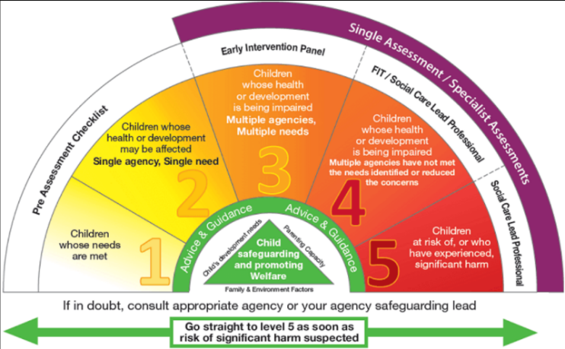
At UKLC, our students are only with us for a short time and as such it is less likely that we will encounter elements of the above. However, we must adopt a “it could happen here” attitude. This means it is paramount that if anyone has any concerns, they must raise them immediately.

Low-level concerns This term does not mean that it is insignificant. A low-level concern is any concern – no matter how small, and even if no more than causing a sense of unease or a ‘nagging doubt’ - that an adult working in or on behalf of the school or college may have acted in a way that:
- is inconsistent with the code of conduct for adults, including inappropriate conduct outside of work and does not meet the harm threshold or is otherwise not serious enough to consider a referral to the LADO.

Examples of such behaviour could include, but are not limited to:
- being over friendly with children,
- having favourites,
- taking photographs of children on their mobile phone, contrary to UKLC policy,
- engaging with a child on a one-to-one basis in a secluded area or behind a closed door, or
- humiliating children.

Such behaviour can exist on a wide spectrum, from the inadvertent or thoughtless, or behaviour that may look to be inappropriate, but might not be in specific circumstances, through to that which is ultimately intended to enable abuse. Low-level concerns may arise in several ways and from a number of sources. For example: suspicion; complaint; or disclosure made by a child, parent or other adult within or outside of the organisation; or as a result of vetting checks undertaken. It is crucial that all low-level concerns are shared responsibly with the right person and recorded and dealt with appropriately. Ensuring they are dealt with effectively should also protect those working in or on behalf of UKLC from becoming the subject of potential false low-level concerns or misunderstandings.

Low level concerns can act as “jigsaw pieces” in the depiction of a larger issue. This is why they are important and why the review and recording of them is so important.

Where a concern or allegation is raised, remember:

Once a concern is raised, it is the responsibility of the DSP to respond:
- Sensitively gather more information
- Record everything
- Inform the people who need to know and no others
- Act according to investigations and discussions
- Monitor as required until No Further Action (NFA) can be noted

And follow the procedures below:

Procedure A (where a concern is raised about a possible abuse during the young person’s stay):
Should a member of the UKLC team or homestay host have a concern that abuse has occurred or is likely to have occurred during the young person’s stay, the following action should be taken:

- Inform one of the Designated Safeguarding Persons (DSP) at the centre immediately. This will be the Centre Manager, the Safeguarding and Welfare Coordinator or another member of the management team.
- Inform the appropriately trained members of the Senior Leadership team from UKLC Head office. This will be either Jamie Brailsford (Operations Director), Carolyn Rennoldson (Head of People and Culture), Jordan Dallimore (Head of Operations)
- Make sure the young person is safe and supported / reassured. Remain calm and try to return the young person to their normal routine if that is safe and appropriate.
- Ensure that a clear written record has been made using the Concern/Allegation Form (APPENDIX 9 – Concern/Allegation Form) or the Prevent Form (APPENDIX 10 – Prevent Form), that it is signed and dated by the person who raised the concern / made the allegation / heard the allegation from the young person and pass it on to the Senior Leadership team as soon as possible.
- The Senior Leadership team will, where appropriate and if necessary, contact as soon as possible the Local Area Designated Officer (LADO) or Local Prevent Co-ordinator (LPC). No decisions will be made without the LADO’s or LPC’s agreement. The contact details for the relevant LADO and LPC can be found in APPENDIX 8 – LADO and PREVENT Contact details per centre.

Procedure B (where a concern is raised about abuse in the student’s home setting)
Should a member of the UKLC team or host have a concern that abuse has occurred or is likely to have occurred in the young person’s home country, the following action should be taken:

- Inform one of the Designated Safeguarding Persons (DSP) immediately. This will be the Centre Manager or another member of the management team.
- Inform the appropriately trained members of the Senior Leadership team. This will be either Jamie Brailsford (Operations Director), Carolyn Rennoldson (Head of People and Culture), Jordan Dallimore (Head of Operations)
- The Senior Leadership team will, where appropriate, contact as soon as possible in the following order:
- Group Leader
- Agent/ETO
- Parent (at discretion of Agent)
- Ensure that a clear written record has been made using the APPENDIX 9 – Concern/Allegation Form and that it is signed and dated by the person who raised the concern / made the allegation / heard the allegation from the young person and pass it on to the Senior Leadership team as soon as possible.

Procedure C (where a concern or allegation is raised about a member of the UKLC team)
These procedures must be followed if there is a concern or allegation that a member of the UKLC team has:
  - behaved in a way that has harmed a child or may have harmed a child
  - possibly committed a criminal offence against or related to a child
  - behaved towards a child or children in a way that indicates s/he may pose a risk of harm to children
  - behaved or may have behaved in a way that indicates they may not be suitable to work with children.

*Important to note here that this also covers transferable risks, i.e. behaviour that may have happened outside of
The UKLC centre but that might make an individual unsuitable to work with children.

- Inform one of the Designated Safeguarding Persons (DSP) at the centre immediately. This will be the Centre Manager or another member of the management team. If the concern is regarding one of the management team, go straight to point 2.
- Inform the appropriately trained members of the Senior Leadership team from UKLC Head office. This will be either Jamie Brailsford (Operations Director), Carolyn Rennoldson (Head of People and Culture) or Jordan Dallimore (Head of Operations)
- Make sure the young person is safe and supported / reassured. Remain calm and try to return the young person to their normal routine if that is safe and appropriate.
- Ensure that a clear written record has been made using the Concern/Allegation Form (APPENDIX 9 – Concern/Allegation Form) or the Prevent Form (APPENDIX 10 – Prevent Form), that it is signed and dated by the person who raised the concern / made the allegation / heard the allegation from the young person and pass it on to the Senior Leadership team as soon as possible.
- The Senior Leadership team will, where appropriate, contact as soon as possible the Local Area Designated Officer (LADO) or Local Prevent Co-ordinator (LPC). No decisions will be made without the LADO’s or LPC’s agreement. The contact details for the relevant LADO and LPC CAN BE found in APPENDIX 8 – LADO and PREVENT Contact details per centre.

- In all cases any action taken, monitoring done, and any further developments/discussions should be added to the written records of allegations (on the reverse of the form)

- Any person (team member or host) dealing with an allegation will ensure that they take into consideration that it may be necessary to protect the relevant young person following an allegation of abuse or neglect. They will therefore request guidance from the LADO as to whether they are able to contact the parent or carer, via the Agent, of the young person concerned following a referral or allegation of abuse.

- If the concern or allegation is made against a member of the UKLC team, the SLT would contact the LADO, and no action would be taken to inform the member of the team or suspend them until the LADO had been contacted. As with all cases, discretion and confidentiality would be paramount and any information would be restricted to as few people as possible.

- Records of Concerns/Allegations are highly sensitive. They should only be held by a DSP at the centre in a lockable place and should be handed over to the Senior Leadership team at the first opportunity. They will then be securely stored at Head Office separate from student or staff records.

- On an annual basis the Senior Leadership team will do a Safeguarding Audit and write a report. They will be looking to check the number of concerns raised, if there are any patterns and how effective the overall safeguarding strategies have been. The report will also detail any Child Protection training done by team members, when next training is due and any feedback from relevant team members (Centre Managers and Safeguarding & Welfare Co-ordinators) regarding safeguarding and Child Protection at their centres.

A note on record keeping:
- All Concerns must be recorded. This single piece of information might be part of a larger, possibly ongoing, situation - or the start of a new one.
- The person raising concern needs to write and sign the initial report (APPENDIX 9 – Concern/Allegation Form) Designated Staff then take over and continue adding to the record as required.
- Records need to be easy to access, but not by everyone.
- Information logged as a concern is not usually confidential. It may become so after further investigation or later (if the concern turns out to be more serious)
- Records can be helpful in identifying patterns in safeguarding when data is extracted. It is important to compile a detailed chronology. It may be useful in an investigation or in a negligence claim.
- When writing what the student has said (disclosure) use the exact words that student used. Do not ‘tidy up’ or translate on their behalf.
- The Data Protection Act 2018 and GDPR do not prevent, or limit, the sharing of information for the purposes of keeping children safe. Fears about sharing information must not be allowed to stand in the way of the need to safeguard and promote the welfare of children.
- Records pertaining to Child Protection concerns must be kept until the child has reached the age of 25, records pertaining to concerns about employees must be kept until they have reached retirement age or for 10 years, whichever is longer.

PREVENT
The Prevent duty requires all education providers ‘to have due regard to the need to prevent people from being drawn into terrorism’. This includes safeguarding children, young people and adult learners from extremist ideologies and radicalisation. We understand extreme ideologies to be varied and include any far right thinking or Incel culture.

At UKLC our centres can be a melting pot of different cultures, nationalities and backgrounds. Our Diversity, Equity and Inclusion policy states that everyone deserves to be treated with dignity and respect. We aim to promote core British values to the students via specific lessons and the conduct of our teams.

All adults are expected to have an “eyes and ears” approach to any extremist views that are expressed and immediately raise a concern with the management team. The procedures to be followed are then exactly as per the Child Protection policy above.

SUPERVISION

Policy
UKLC supervise all students by providing the following:
- A student/adult ratio in line with good practice guidance,
- Supervision of young people at all times, in classes, activities and excursions,
- Full registers for all classes and morning/afternoon/evening activities and excursions,
- Wristbands, which are worn by every student,
- Identification lanyards for every student, group leader, UKLC team member and visitor.

Sports instructors are qualified in National Governing Body awards (where possible). Supervision of swimming pools (where relevant) will be undertaken by RLSS National Pool Lifeguard Qualified staff. Where a specialist course is provided, such as dance, drama or tennis , staff with specialist qualifications are employed to deliver that element of the course.

Outside of agreed times, group leaders will supervise their groups with the constant support of the UKLC team. The role and responsibilities of the group leader are detailed in the Group Leader Handbook and group leaders are asked to sign off to these responsibilities at site (APPENDIX 11 – Centre Residential Group Checklist) and attend group leader training.

For individual students travelling without a group leader, they will be allocated a UKLC team member to act as their group leader and point of reference at all times. In centres with under 6 individual students enrolled, this responsibility will fall to the Safeguarding and Welfare Co-ordinator. Over 6 enrolled students, UKLC will appoint someone as a UKLC Group Leader.

At Individual centres, the UKLC team provide 24-hour supervision of students, from their arrival in the UK to their departure through passport control at the airport (additional supervision is given to students travelling as unaccompanied minors). House Parents are employed to provide pastoral care during the night and other times when student(s) are in the residence. The Safeguarding and Welfare Co-ordinator supports the work of the House Parents.

Procedure
- It is important that all team members are made aware at induction of their responsibilities in supervising and looking after students at our centres. The students’ safety and security are of paramount importance.
- On arrival, students should be issued with wristbands and lanyards and told to wear them at all times or sanctions will be applied.
- When organising activities (excluding classroom teaching) on-site and, in particular, excursions and visits off-site the supervision ratios need to reflect on the basis of risk assessments, the activity to be undertaken and the age and maturity of the students.
- In residential accommodation the ratio of residential adults to students will be at least 1:20 for students aged 12 and over, and 1:15 for students under 12.
- Group leaders can be included in ratios, although only in relation to their own group.
- Group leaders can only be there in a supporting role, and we still provide a sufficient level of UKLC team members’ involvement to ensure proper organisation and leadership of all activities and excursions. In each centre the Centre Manager will be the person with ultimate responsibility for student welfare* and they will be supported by a Safeguarding and Welfare Co-ordinator. The Centre Manager and Safeguarding and Welfare Co-ordinator need to be named and introduced at every welcome talk.
- Registers are taken for all classes, organised sports activities, evening activities and excursions.
- We ensure that there is proper supervision at break times and during mealtimes by establishing a team rota.
- For evenings and night-time, we have a clearly laid out rota of who is responsible at what times for seeing that students are well-behaved and do not cause excess noise late at night.
- Evening activities generally finish between 9.30pm and 10pm however we suggest the following bedtimes:
  - Students aged 10 and under – finish activities at 9pm and are in bed by 9.30pm
  - Students aged 13 and under – finish activities at 10pm and are in bed by 10.30pm
  - Students aged 14 to 17 – stay up a little after evening activities and are in bed by 11pm

- NOTES FOR HOMESTAY STUDENTS: UKLC is committed to providing a safe and secure environment for your students, therefore homestay curfews for students are:
  - Students aged 14 and under must return straight home at the end of a day.
  - Students aged 15 and over can organise a special curfew with permission from their parents, and agreement from the hosts, up to a deadline of 9pm (this curfew can be extended to 10pm for students aged 17 and over)

- In UKLC programmes, we ensure that all students have returned safely to their rooms and are going to bed, by asking the group leaders to message the UKLC duty phone once this is the case.
- On our individual programmes, our team does a last check in the evening to ensure everyone is safely in bed.
- On excursions, students are supervised by the UKLC team and their group leader/s. All excursions have an element of free time incorporated into the itinerary if the group leader agrees (if no free time is desired then UKLC team members will continue to supervise the group). Free time is age dependent as follows: under 10 years old – no unaccompanied free time, 11-14 – groups of 4 to 5 students are allowed free time but must return to the agreed meeting point every 30 to 45 minutes (this is city dependent e.g. in larger cities the time will be shorter) and if possible UKLC team members and group leaders will still accompany, 14-17 – groups of 3 to 4 students are allowed free time and must return to the agreed meeting point every 60-90 minutes. On no account should students wander off alone. Students should have their phone, their wristband and lanyard and be aware of the meeting points. (See excursion policy and risk assessments).

* By welfare we mean meeting students’ religious, cultural and dietary needs, helping students deal with any issues relating to harassment, bullying, actual or threatened violence, damage to personal property, verbal and other abuse based on racial, sexual or religious differences.

SAFETY

Policy
UKLC have a policy of ensuring that all reasonable and practical steps are taken to minimise any risks and ensure the Health and Safety of its students, group leaders, team and other relevant people.

To ensure this:

- Risk assessments are drawn up for all elements of UKLC courses.
- All equipment is checked that it is safe for use.
- All UKLC locations are checked that they are safe for use.
- Activities will only take place when terrain and weather conditions are suitable.
- Safety briefings are given with all activities
- Training is delivered on UKLC Operations and Safeguarding Policies and Procedures during Management Training and at all team inductions.
- Adequate supervision, instruction, training and education is provided to all students and group leaders are briefed on their roles/responsibilities and input into sessions if applicable.
- On arrival, students are briefed on road safety, behaviour and bullying, smoking restrictions, discipline, internet safety and provision for help in emergency (999, school emergency number)
- All accidents and incidents, however minor, are recorded on the relevant forms.
- Every student, team member and group leader are fully briefed on the Fire Procedure.
- All relevant emergency numbers are collated and circulated to team members and group leaders.

Procedure
- Before the start of any lessons/activities (instructor-led specific group activities), all the inside and outdoor areas must be checked to ensure that they are safe for the lesson/activity to take place. This must include checks on field areas for objects (broken glass/holes etc.) as well as internal rooms/halls for unsafe equipment and leftover objects.
- All students must be counted before they are taken off to their specific lesson/activity and a register completed. This will be the responsibility of the UKLC team member. If a UKLC team member realises that a student has failed to turn up for an organised lesson, activity or excursion and 15 minutes has passed, they should inform the relevant member of the Centre Management Team.
- In the event of hot weather, make sure the students wear sun hats or wear some kind of protective cream. The team member reserves the right to take students indoors if they feel it necessary. UKLC team members will never apply protective cream to students.
- In the event of cold weather, ensure that students are adequately dressed in coats and hats, gloves if necessary. The team member has the right to cancel the activity in the event of bad weather or refuse any students that they feel are not suitably dressed for the activity.
- If a student requires First Aid, they must be escorted by a team member to a First Aider (see First Aid policy).
- Students that need the toilet should first ask the UKLC team member supervising them. The team member should make a mental note of the time and where a student does not return within a reasonable amount of time, the location of the student should be ascertained. UKLC team members should not enter the toilet area with a student on a one-to-one basis.
- Where lessons/activities allow, team members should ensure that all the students are in their visual range. In the event of any activities that cover larger areas (Scavenger hunt etc.) staff should agree short timely check-ins with their students.
- The appropriate staff ratios will be met for all lessons/activities. Operating procedures and risk assessments will be made available.
- The correct size of equipment should be used for the relevant age group of the students. At the end of the day when the students have returned to their rooms and gone to bed, the group leader will complete a final check to ensure all their students are there and send a message to the UKLC duty phone to say that all are present and correct.

CENTRE MANAGEMENT & RESPONSIBILITY

Policy
UKLC appoint a residential Centre Manager for every centre. This person carries overall responsibility for the site, students, group leaders and the onsite UKLC team. They are supported 24 hours a day by the Senior Leadership team. In their absence, another member of the management team will be appointed as Duty Manager and will take over the site duty phone.

Procedure
A clear rota for time off will be established for the management team.

Any time the Centre Manager is handing over to another member of the management team, the Senior Leadership team must be informed.

The appointed Duty Manager will take over the duty phone and deal with any issues that arise.

However, if important decisions need to be taken (e.g. change in the programme, discipline of a student, action regarding a complaint from a group leader, safeguarding issue etc.) or if a serious incident occurs then this Duty Manager will only proceed under the direction of the Senior Leadership Team.

INTERNET AND TECHNOLOGY SAFETY
Policy
Young people are often more comfortable and savvier using technology than adults. They are also much more trusting and believe what they read; this makes them particularly vulnerable. There are many websites offering illegal or inappropriate material, for example, pornography, promoting self-harm, drinking games, hate sites etc.

It is our responsibility to protect the students on our courses from coming into contact with such sites. It is also our responsibility to promote online safety and education about the dangers of the internet and social media to the young people whilst they are away from home.

Procedure
- We contact all our hosting institutions and establish what filters/ blocks are in place in their systems
- We introduce our students to SIS, our Safest Internet Student and how she behaves via posters in the classrooms and around the centres.
- All students have a level specific lesson in online safety during their first week
- In our Welcome Talk, students are warned about accessing inappropriate sites and are told that Mr IT manager is watching!!!
- In our team training, we include an element of online safety and ask them to be “eyes and ears” when around the students and immediately raise any concerns with their management team.
- We ask our homestay providers to give information given to hosts about managing internet safety in their homes

ARTIFICIAL INTELLIGENCE (AI) in Academic Work
Policy
Artificial Intelligence (AI) tools such as text generators, translation software and chatbots may be used by students to assist with language learning. However, UKLC expects all students to complete their classroom tasks honestly and to demonstrate their own learning and ability.

The use of AI tools must not undermine the purpose of the course, which is to develop students’ English language skills through personal effort and participation.

Students must not:
- Use AI tools to complete written tasks that are intended to assess their own work
- Present AI-generated content as their own work
- Use AI tools during tests or assessments unless explicitly permitted by a teacher
- Use AI to generate inappropriate or harmful content

Teachers may allow limited AI use where it supports learning, for example:
- vocabulary support
- grammar explanation
- idea generation
- language practice

However, this must always be supervised and explained clearly to students.

If misuse of AI is identified, teachers may:
- ask students to redo the work
- record the incident as inappropriate behaviour
- inform the Centre Management team where necessary.
Repeated misuse may be addressed through the Behaviour Policy.

STAFF USE OF ARTIFICIAL INTELLIGENCE (AI)
Policy
UKLC recognises that AI tools may assist team members with tasks such as lesson planning, administrative work or language resource creation. However, the use of AI must always be ethical, responsible and compliant with safeguarding and data protection requirements.

AI tools must never replace professional judgement, particularly in matters relating to safeguarding, behaviour management or student welfare.

Team members must not:
- Upload or share student personal data with AI tools
- Input confidential safeguarding information into AI systems
- Generate or store images or media involving identifiable students using AI tools
- Rely solely on AI-generated content without reviewing its accuracy and appropriateness.

Any materials generated using AI must be checked carefully to ensure that they are accurate, appropriate for the age group and culturally sensitive.

DATA PROTECTION AND PRIVACY WHEN USING ARTIFICIAL INTELLIGENCE (AI)
Policy
AI systems may collect and process data entered by users. For this reason, UKLC must ensure that the use of AI tools complies with the UK GDPR and Data Protection Act 2018.

Team members and students must not enter the following information into AI systems:
- student names or identifying information
- medical or welfare information
- safeguarding concerns
- contact details
- internal UKLC documents or confidential information.

If an AI tool is used for educational purposes, team members should ensure that:
- it is appropriate for use with under-18s
- it does not collect unnecessary personal data
- it aligns with UKLC safeguarding and data protection policies.

Any concerns regarding misuse of AI or potential data breaches must be reported to the Centre Manager and Senior Leadership Team immediately.

ARTIFICIAL INTELLIGENCE (AI)
Procedure
UKLC will promote safe and responsible use of AI technologies through the following measures:

Student awareness
- During the Welcome Talk and online safety guidance, students will be informed that AI tools may produce inaccurate or inappropriate information.
- Students will be reminded not to share personal or identifying information with AI systems.
- Students will be informed that AI must not be used to generate harmful, offensive or misleading content or to impersonate others.
Monitoring
- As students generally access AI tools via their personal devices, direct technical monitoring is limited. However, UKLC team members are expected to remain vigilant to signs of inappropriate or unsafe use.
- Any concerns relating to AI misuse (e.g. harassment, inappropriate content, impersonation or safeguarding concerns) must be reported to the Centre Manager or Safeguarding and Welfare Co-ordinator in line with existing safeguarding procedures.
Teaching and academic use
- Teachers may discuss AI tools as part of digital literacy and language learning where appropriate.
- AI should not be used by students to complete assessed work or tasks intended to demonstrate their own language ability unless explicitly permitted by the teacher.
Staff use
- Staff using AI tools for lesson preparation or administrative tasks must ensure that no student personal data, safeguarding information or confidential UKLC material is entered into AI systems.
- All AI-generated materials must be checked carefully to ensure they are accurate, age-appropriate and culturally appropriate before being used with students.
Reporting concerns
- Any concerns relating to AI misuse should be addressed through existing procedures and recorded where appropriate using an Incident Form or Concern/Allegation Form, depending on the nature of the issue.

FIRST AID

Policy
There will always be at least one First Aid qualified member of the team on site. The location of all First Aid boxes must be known to the qualified members of the UKLC team.

Procedure
First Aid should only be administered by somebody who is First Aid qualified. Only administer if necessary. If First Aid has been administered, please notify the Centre Manager of details and complete the First Aid usage form (APPENDIX 12 – First Aid Usage Form) in the First Aid box. The details of any accident or incident should then be recorded on the relevant form.

Always be accompanied by another person when administering First Aid. Be aware of dignity and feelings when administering First Aid. If a member of the team does not feel confident in their ability to deal with the situation, they should contact another member of the team or call for an ambulance if necessary.

INCIDENTS

Policy
All incidents that are deemed worthy of note should be recorded correctly at site and appropriate signatures taken. Records are to be kept on file for three years.

Procedure
Incidents are classed as:

Unusual behaviour, unexpected visitors to the group, odd or unsuitable actions or behaviour by students, group leaders or UKLC team members, fighting and intense debate / argument, any unacceptable behaviour, existing injuries, any other issue that the team feel should be recorded. (If in doubt, speak to a DSL at the centre to ascertain if your incident needs a Concern form).

Note: Any incident resulting in an injury should also be entered on an accident form

- Note the student’s name/s, group, group leader, date, time, type of incident, the action taken and UKLC team member on the Incident Form (APPENDIX 13 – Incident Form),
- Write a full report of the incident,
- Make sure that the form is signed by the students’ group leader, the UKLC team member and the Centre Manager,
- Ensure, where applicable, that group leaders are informed of the incident and any actions taken by a UKLC team member,
- Name any witnesses to the incident if the seriousness of the incident requires it,
- Think - does an accident form need to be completed? Does a Concern form need to be completed?

ACCIDENTS
All accidents should be recorded correctly at site and appropriate signatures taken. Records are to be kept on file for three years.

Procedure
All accidents must be recorded on an Accident Form (APPENDIX 14 – Accident Form).

- Note the student’s name/s, group, group leader, date, time, type of accident, action taken and the name of the UKLC team member who dealt with the accident.
- Write a full report of the accident
- Make sure that the form is signed by the students’ group leader, the UKLC team member and the Centre Manager.
- The accident record should always be signed by a UKLC team member who either dealt with the accident or who witnessed the accident and any treatment given.
- In the circumstances of any significant injury, the names and addresses of any witnesses should also be recorded.
- Injury to any students, members of staff or visitors should be recorded.
- Think, does an Incident form need to be completed? Does a Concern form need to be completed.

Please ensure that the Senior Leadership Team is informed of any incidents / accidents that occur. It is their responsibility to report any concerns to the relevant authorities, such as RIDDOR, should it become necessary.

RIDDOR Notes

Reporting of Injuries, Diseases and Dangerous Occurrences
- All accidents or incidents that fall within this category will be reported as soon as possible after the injury, disease or dangerous occurrence has occurred.
- All of the above must be reported to the Centre Manager who will then forward this information to the UKLC head office and make the Senior Leadership Team aware of the incident.
- For any person who is taken to a hospital for an injury or disease, this will be reported on the incident and accident forms and online report completed for RIDDOR.
- All incidents can be reported online but a telephone service is also provided for reporting fatal/specified, and major incidents only - call the Incident Contact Centre on 0345 300 9923 (opening hours Monday to Friday 8.30 am to 5 pm).

MEDICATION and ALLERGIES

Policy
It is rare for students to receive medication whilst with us, but on occasion a student will arrive with a pre-existing condition that requires regular medication. All medical information is requested at enrolment (see enrolment policy) and further confirmed with the student and the group leader upon arrival. If necessary, medicine is usually administered by the student or group leader or in some cases we are asked to source some local medical care.

Students with allergies will be accepted on our programmes where the hosting venue agrees to cater for their requirements. We will always make every effort to accept a student with allergies and to ensure that this is managed appropriately by the team and the catering at site.

On Individual programmes all medical information is collected at enrolment and confirmed with the student upon arrival. If any medication is required then all details will be sent by the agents prior to the student arriving.

Procedure
Any medical information (including allergies) is collected prior to the arrival of the students, via the agent/ETO. This information is recorded on a centre specific student database and is available* only to the Centre Management team and is shared*, if relevant, with the hosting organisation’s team. Any medical information for a student in homestay will be passed to the host provider. We also ask all students to complete an enrolment form upon arrival that records any medical issues. This information is cross referenced with the database.

If a student has a serious allergy or requires medication during their stay with UKLC, we will ask for detailed information from the agent about this. This may include a list of what they can or cannot eat, products they must avoid, any medication they are taking, how often, how it needs to be stored and administered. This information* is generally received via email from the agent and is passed to the centre management team and the catering team where necessary.

*Extra attention is given to the security of such information as it is considered to be special category data.

HEALTH

Policy
It is our policy to encourage and promote good health and hygiene to all young people and adults who come to UKLC. Whilst under the supervision of UKLC, students’ health will be monitored, however, students should take responsibility for their own care wherever possible. If we feel a particular student is not well enough to carry on with a particular activity, we reserve the right to remove them from the activity.

Procedure
The following list details our hygiene measures:

- Students are encouraged to always wash their hands with hot soapy water for more than 20 seconds,
- Students will be required to wash their hands before and after lessons, activities, excursions and mealtimes,
- Hand sanitisers to be made available,
- Always cover cuts and open sores with a plaster,
- Always use plastic gloves when dealing with spilled bodily fluids,
- Splashes in the eyes/mouth should be rinsed with warm water,
- Report all accidents and incidents on the relevant form.

As can be seen in our Enrolment Form (APPENDIX 5 – Enrolment Form) we ask for as much relevant information about our students as possible.

We do this to:
- Make our team aware of any possible health restrictions or medical conditions
- Make the students’ time with us more comfortable and enjoyable.
- Guard against any health and safety issues – where health may compromise the safety of a particular activity.

If a student requires hospital treatment, a relevant group leader should accompany the injured/sick person to the hospital. If a group leader is not available a member of the UKLC team will accompany the student. The Centre Management must be informed and the Senior Leadership Team notified too. The UKLC team member should ensure that they have a working mobile phone. On return to site, an Incident Report Form should be completed.

In the event of serious accident or illness, the relevant professional medical help will be sought. The group leader will be informed, and the agent/ETO/parents/guardian contacted. In the event of the group leader not being available, a UKLC team member or host will take charge and take the student to hospital. All available details of the student will be given to the medical practitioners.

In the event of a student requiring urgent medical attention where consent must be given, the group leader will immediately contact the parents/guardian. If the parents/guardian cannot be reached, the group leader will, in conjunction with the agent/ETO, take any necessary decision. If the group leader cannot be found, a member of UKLC Senior Leadership team will confer with the parents/guardian and/or agent/ETO to make a decision. If the parent and/or agent/ETO cannot be reached, a member of UKLC Senior Leadership will confer with the group leader to make a decision. Where necessary UKLC Senior Leadership will make a decision.

INFECTIOUS DISEASES
UKLC Policy and procedure regarding infectious diseases and how to avoid and/or manage an outbreak in one of our centres. This policy has been taken from the https://www.gov.uk/government/publications/health-protection-in-schools-and-other-childcare-facilities Please refer to this document for exclusion times and details of specific infectious diseases. Please also use this in cases of outbreak and to find the contact details of the relevant authority listed or Health Protection Team (HPT).

Policy
Control of infection among students at UKLC centres depends upon:
- Prevention
- Early recognition of each case
- Prompt action and follow up

Infections may be:
- Acquired in home country and carried in OR
- Acquired and spread within the centre.
- What is an outbreak? An outbreak is defined as two or more linked cases with similar symptoms over and above that which would normally be expected. If there is an outbreak, the Centre Manager must contact the Senior Leadership Team who will decide if the local health protection team needs to be contacted.

Procedure
- Washing hands properly is one of the most important things individuals can do to help prevent and control the spread of many illnesses. Good hand hygiene will reduce the risk of illnesses like Covid 19, flu, stomach upsets and other infections being passed from person to person. Good hygiene is to be promoted in all centres and students must be reminded to wash their hands before meals and after activities and excursions.
- Dealing with any cuts/abrasions or body fluid spills. Standard precautions are a set of infection control practices used to prevent transmission of diseases (such as Hepatitis C and HIV) that can be acquired by contact with blood, body fluids, non-intact skin (including rashes), and mucous membranes.
- Standard precautions should be used for everyone to reduce the risk of unknown (and known) disease transmission and include:
- Wearing gloves when in contact with any accident or injury (washing grazes, dressing wounds, cleaning up blood after an incident) and wearing a disposable plastic apron if possible.
- Carefully cleaning the wound under running water if possible or using a disposable container with water and wipes. Dab carefully dry.
- Covering all exposed cuts and grazes with waterproof plasters.
- If someone suffers a bite, scratch or puncture injury that may have introduced someone else’s blood or experiences a splash of blood to the eye, area of broken skin or mouth, rinse well with water and seek medical advice.
- Illnesses to look out for that will require action are Chicken pox, Measles, Conjunctivitis, Head lice, Gastroenteritis. (Please find a full list on the link above with details of symptoms and exclusion periods)

If symptoms start whilst a student is at a UKLC centre:
- Isolate them away from other students immediately and until they are well or no longer contagious (this would potentially be in a medical room or a designated separate accommodation).
- Ensure that a dedicated toilet is nearby which should only be used by symptomatic students / staff.
- All lever/light switches, handles and other ‘high contact’ items must be cleaned regularly with detergent and water and then disinfected with a hypochlorite solution. Bathrooms should also be thoroughly cleaned as above.
- Wash any soiled laundry or clothes separately on a wash that is stated by the wash label.
- Ensure appropriate personal protective equipment such as gloves and aprons are worn when any personal care is given, or cleaning is undertaken.
- Ensure good hand hygiene is undertaken.
- Consider access to handwashing facilities near the dining room as hands should be cleaned before a meal and consider handing out antibacterial gel to the students.
- Contact the Senior Leadership Team who may in turn contact the local health protection team for further advice and guidance.

School lockdown/ closure
We follow government guidance on infection prevention and control. We aim to reduce the risk of transmission and therefore a closure of the whole setting will hopefully be extremely unlikely.

However, it is possible that a large number of students may be asked to self-isolate in their accommodation if there are many students presenting with the same symptoms. In the first instance, we would aim to isolate one block of accommodation for those needing to isolate.
Rest assured that the closure of a centre would be a last option after all other mitigating measures had not worked. Such measures would include:
- Delivering provision as normal but with additional cleaning / social distancing measures in place,
- Partially opening the centre to a limited number of students,
- Asking a partner/sister school for assistance.

In this scenario, we would inform all students, group leaders and agents/ETOs and work with them to arrange transport.

FIRE SAFETY

Policy
UKLC takes fire safety extremely seriously. The procedures and precautions of the hosting venue are studied and adhered to. The whole UKLC onsite team is trained in these procedures, and all students are made aware of these procedures as soon as they arrive. We organise full site fire drills at every centre.

Procedure
All the Fire precautions at the hosting organisation should be checked and the whole team must be made aware of them at induction. As part of the pre-course preparations, all fire exit notices must be checked to ensure they are in place and are clearly visible. A procedure for organised fire drills must be worked out with the hosting organisation.

Students and group leaders are shown the fire exits as part of their orientation and upon arrival an initial fire drill is carried out. They are informed about the seriousness of abuse of fire equipment and alarms (and the charges which will be levied). If the hosting school/college has a no smoking policy, it is enforced, particularly with regard to smoking in bedrooms.

Fire lists: A list of who is in which bedroom will be completed by the end of the first day of a group’s stay and the record kept in the Centre Manager’s office (the hosting organisation will also be given a copy). An extra copy will be made and placed in the entrance of each accommodation building. The Centre Manager must pay particular care to younger students. Any student under the age of 11 or those needing additional assistance when evacuating must be highlighted on the fire list.

Where UKLC team members are off duty but are residential and may leave the premises for the evening, they must inform the duty manager when they leave and return by way of a what’s app message in a specially created team group.

A full site fire drill will be carried out within the first 24 hours of each new intake to ensure that staff and students are all fully aware of the correct procedure.

A record of all fire drills must be kept by recording the information on a Fire Log Form (APPENDIX 15 – Fire Log Form).

At each centre, the Centre Manager (or on duty member of the management team) is the Fire Officer.

FIRE ACTION

Procedure
On discovery of a fire, sound the fire alarm and alert other adults as soon as possible.

Ensure that one person dials 999 for the Fire Service. Give the following details:
- The full address and area of site,
- Reason for the call e.g. Alarm gone off, fire in building, etc.,
- A contact telephone number.

On the sound of the Fire Alarm, ask students to stop what they are doing and make their way out of the building through the fire door or nearest exit to the assembly point.

If the alarm sounds at night, UKLC team members and group leaders should usher students out of the building taking the fire lists with them. Please be aware that younger students may not necessarily wake up so all adults (UKLC team and group leaders) must wake them up and, if that is not working, carry them out.

Close all doors and report to the assembly point.

The Duty Manager (Centre Manager or member of the Centre Management team in charge that night) should take their copy of the fire lists with them and check the Duty phone to see which UKLC staff are present.

Take a register ensuring all students and staff are present.

Do not re-enter the building until advised to do so.

Assembly Point: (site-specific according to hosting organisation’s fire procedure)

Record all information on Fire Log Form (APPENDIX 15 – Fire Log Form).

VISITORS

Policy
It is UKLC policy that any person (outside of students, group leaders and the UKLC team) visiting a centre should be recorded on a Visitors log. Some examples of visitors could include the following:
- A British Council inspector,
- A Fire Inspection Officer,
- A Policeman,
- A Doctor.

Where hosts are collecting their homestay students from a centre, the UKLC team will meet and familiarise themselves with each homestay host. A list of the names and contact details of each host will be kept by the Centre Manager/Homestay Co-ordinator. Where the normal designated host is not able to collect the students, UKLC will be advised of the name of the person collecting. In this case, identification will be requested.

In this way, any person arriving at site can be verified.

Procedure
The following information should be recorded in the Visitors Log (APPENDIX 16 – Visitors Log):
- Full name of visitor,
- Occupation and place of work,
- Reason for their visit,
- Date and time / length of stay,
- Signature of visitor,
- Signature of person who attended to the visitor.

r? along with a UKLC lanyard.

MISSING PERSONS

Policy
The following policy is to be implemented in the unlikely event of a student going missing whilst on a UKLC programme.

When dealing with a missing person situation, the safety of the students and the team should be of paramount importance and the Centre Manager or Senior Leadership Team should be informed as soon as possible. No emergency or serious incident should be discussed with any person from outside the company, especially, but not exclusively, the press.

Procedures

Missing student from site:
Once the fifteen-minute rule has elapsed and the relevant management team members informed, if the student still has not turned up, follow this procedure:
- Centre Manager to co-ordinate search from centre office,
- CM to try and contact the student via their mobile phone and speak to their friends to ascertain when they were last seen,
- CM starts the clock and initiates a search of the centre (accommodation and grounds) and advises a time for the relevant team members to meet back at centre office and keep in contact via mobiles,
- CM keeps a log of the events, including times and persons involved,
- Ensure adults are properly attired for search e.g. warm clothes / waterproofs, spare clothes,
- Brief the team and delegate search areas,
- If necessary, use the fire alarm to get a definitive count and check of who is in the building,
- Upon exploration of greater than one hour, inform the police and request assistance,
- Everyone involved in the search to return to centre office at a designated time,
- CM passes responsibility for searching to the Police on their arrival,
- Once a student has been missing for over two hours the SLT will confer with the group leader about informing the parents/guardian.

Missing student on excursion
- On the coach before letting the students go, UKLC team members must brief all students on what to do if they get lost and stress to students that they should always have the 24hr emergency number with them (on their wristbands): 00 44 1244 567 695,
- If a student fails to turn up at the meeting point, the UKLC team members should try and contact them via their mobile phone and speak to their friends to ascertain when they were last seen,
- Any group leader missing a student should always return to the meeting point to find them and immediately inform a member of the UKLC team,
- If the missing student incident occurs in the morning or while visiting the first of two destinations in one day, the Excursion Leader (UKLC team member in charge of the excursion) should remain at the first destination and continue trying to find the student(s). If they turn up, the EL and the student/s should make their way to the second destination to meet up with the rest of the group and the coach. (If they will not make it to the other location before the scheduled departure time, the EL should call one of the other team members and arrange for the coach to come and pick them up on the way back to the centre),
- If a student is lost and everyone is being significantly delayed (over an hour), then one adult should remain (either the Excursion Leader or another member of the UKLC team or a group leader if they speak good English and they have another leader / a member of the UKLC team to take over the rest of their group) at the departure point. Make sure they have all phone numbers and enough money to get themselves and the student home, then the rest of the group should return to the centre,
- The EL should remain in contact with the Centre Manager (back at the centre) and if the student still fails to turn up, the SLT must be informed,
- If the student has not turned up after an hour, then the Police should be informed, and assistance requested,
- The EL passes responsibility for searching to the Police on their arrival and maintains contact with the Centre Manager/SLT,
- Once a student has been missing for over two hours the SLT will confer with the group leader about informing the parents/guardian.

SUSPECTED INTRUDER/LOCK DOWN
UKLC ask for all emergency and lock down procedures from each hosting organisation.

If a situation occurs where there is a suspected intruder in a UKLC centre, initiate lock down and follow these steps:

- Call the police immediately and where it is known, activate the host organisation’s lock down procedure,
- Inform all UKLC staff and group leaders of the situation (this may be done via WhatsApp groups).
- Stay put and where possible locked in with any students/team members in the vicinity,
- Where students/team members are in an open/public space, seek a safe secure place,
- Handover to the Police/emergency services when they arrive, helping where appropriate or safe to do so.

TRANSPORT

Policy
UKLC will operate the following procedures on company vehicles and contracted or hired vehicles or when students are using public transport.

Procedure

Company vehicles:
- Will be fully insured with comprehensive cover for business use,
- Will provide seat belts for all passengers,
- Drivers will hold a full driving licence,
- All drivers will hold a full driving licence and have a current DBS check,
- Drivers carrying young people (accompanied by another adult) will be over 21 years of age.

Contracted or Hired vehicles:
- Will be fully insured with comprehensive cover for business use,
- Will provide seat belts for all passengers,
- All drivers will hold a full driving licence and have a current DBS check,
- All drivers carrying young people will be over 21 years of age,
- Coach companies used will be regular providers of school transport services, meeting young person regulations and copies of their current Operating Procedures are requested and held on record at Head Office.

Homestay Students on public transport:
- The minimum age for students to be allowed to travel on public transport alone in order to reach their homestay is 13 years. Students will be given all necessary information regarding their journey to and from school and will be accompanied by an adult on the first journey.

Groups on public transport:
- Each group of students accompanied by their group leader will be assigned a UKLC team member to guide them.
- Departure times for groups will be staggered in order to prevent too many groups at a time getting onto tube trains/trams.
- Getting on and off the tube/train/tram: The procedure for getting a group onto the tube/train/tram is that the group leader should get on first followed by the students and the UKLC team member should get on last after ensuring that everyone else is on board. When disembarking, the same applies but in reverse with the UKLC team member getting off last once everyone is off.
- Potential problems: If not all the students make it onto the train in time, the UKLC team member will remain behind with those left on the platform/tram stop. They will then get on the next available correct train. The group leader on the train will continue to the destination station if direct and await the rest of the group. If the journey involved a change, then the group leader should wait at the station/stop at which they were meant to change trains, on the platform with their students (in this scenario they need to pick a lead student to get off first and the leader should get off last). They should then all wait for the remainder of the group with the UKLC team member to meet them. If only one student is ever left behind at a station on their own, then we operate a STAY PUT policy. The student should not move from where they have last been seen until a member of staff comes to get them. The UKLC team member would get off at the next stop and return to where the student was left. The rest of the group carries on as above to either the final destination or the change station and waits there for the missing student and UKLC team member to join them. If it is the group leader who fails to get on the train, then they should catch the next correct train to join the group who will wait for them at either the destination station or the change station. In all these scenarios where part of a group has gone ahead and are waiting for someone to catch up, they should wait for a maximum of 45 minutes after which time they need to (come out of the tube station and) call the Centre Manager.
- It is very important for UKLC team members and Group Leaders to exchange telephone numbers when out and about on trips.

EXCURSIONS

Policy
When taking the students out of the centre on an excursion, their safety is our first concern. Everything is done to ensure that all students, group leaders and UKLC team members are fully briefed about the excursion and have all the necessary information to hand. On the excursion the UKLC team and group leaders must work together in order to ensure that the excursion goes well, and all students return safely.

Procedure
All team members who are going on an excursion:

- Should attend a briefing with the Centre Management Team and receive an itinerary,
- Should read the relevant Risk Assessment for that excursion and the Risk Assessment for free time on excursions and sign off the ‘Read Risk Assessment Form’,
- Should read the UKLC Team Excursion Information Sheet (APPENDIX 17 – UKLC Team Excursion Information Sheet),
- Will have an accurate register of who is going on the excursion.

All group leaders who are going on an excursion:
- Should attend a briefing with the Centre Management Team and receive an itinerary,
- Should read the relevant Risk Assessment for that excursion and the Risk Assessment for free time on excursions and sign off ‘Read Risk Assessment Form’,
- Will have explained to them their role on the excursion with regards to the safety and supervision of their students,
- Will have their list of students and contact details with them.

The Management Team will ensure that:
- There will be a minimum of two team members on any excursion (one will take the role of Excursion Leader). The Group Leaders will be counted as part of the adult/student ratio (only in relation to their own students). This ratio will be a minimum 1:20 (or 1:15 where there are under 12s and 1:10 where there are 8 to10 year olds), and where possible 1:15 or better.
- Each student is issued with a wristband and lanyard, and before departure team members should ensure students have them on.
- Before the coach leaves the centre, all group leaders have confirmed numbers and UKLC team members on each coach have completed a register and head count. (The Excursion Leader will ensure that this is repeated before departure to any second or subsequent destination, and then again before returning back to the centre).
- The Excursion Leader will have a working mobile phone and a First Aid kit and will stay in regular contact with site.

For excursions, UKLC will acquire venue risk assessments prior to the visit so that they will be factored into our own risk assessment and guidance for the team and students.

MAJOR SERIOUS INCIDENT

Policy
A major serious incident (MSI) may involve such occurrences as a death, a serious accident, a fire, an explosion, a missing or abducted student, an accusation of abuse, an accusation of extreme radicalisation or any incident that has significant Health and Safety implications that may damage or harm the reputation or image of UKLC or the centre. In the event of an MSI, the following procedure should be followed.

Procedure
- Follow Emergencies Procedures for each individual incident e.g. fire, missing student, act of terror etc. If unsure, inform most senior member of the Management Team on site at the time.
- All Centre Management should be informed immediately; they should relieve themselves of all duties and assemble in the UKLC office. If the Centre Manager is not present, then the Course Director or Excursion & Activities Manager should be informed immediately. The UKLC Senior Leadership Team should be informed as soon as possible. The lead contact from the Hosting organisation should be contacted and informed of the current situation.
- Management personnel should be deployed at the various access points of the centre, such as at the main gate. The team can be used for various tasks deemed appropriate by the management. Unwanted visitors such as the press or the general public should be prevented from entering the centre. At this point no one should pass comment to any non-management persons. Personnel from the hosting organisation should be told not to comment.
- If the incident has involved students, then a group leader meeting should be held, firstly with those group leaders primarily involved and then possibly, at a later time, with all group leaders to inform them of the incident.
- If the incident has involved a member of the UKLC team, then a team meeting should be held as soon as the timetable and incident will allow.
- If informing next of kin, group leaders/agents or Senior Leadership should advise them to contact the hospital for information. In no circumstances should next of kin be informed of a death over the phone by non-qualified persons.
- Directors of the company will be informed of the incident by the Senior Leadership Team.
- Under no circumstances should anyone talk to or inform anyone outside the organisation, especially any members of the press or general public.

A large outbreak of Covid-19 at a UKLC centre would be considered to be a Major Serious Incident and would be handled as per the Infectious Diseases policy in this handbook.

ACT OF TERROR

Policy
In the event of a terrorist attack in the UK, the following procedures should be followed.

Procedure

Scenario A
If there is a terrorist attack in the UK whilst we have students resident or on an excursion in the city or town of the attack but not directly involved or seemingly at risk, the following procedure should be followed:
- Account for all students in the town or city that has been attacked
- Recall all students back to their centre
- Ensure that every student contacts home to say they are ok

- Accounting for every student. If the attack has occurred whilst the students were on an excursion in the area, the UKLC team member accompanying them must make contact immediately with the Centre Manager at their centre to inform them that all students are present and accounted for. The Centre Manager must inform the Senior Leadership Team.
- Recall to centre: In this scenario the excursion would be abandoned and arrangements to transport the students back to their centre need to be made. The Centre Manager will oversee this under the direction of the Senior Leadership Team. If they have been on private transport, then usually this will be reorganised to bring them back to the centre early. If they have travelled on public transport and transport has been suspended, then the SLT will organise an alternative for them. The accompanying UKLC team member must act responsibly in order to keep the students calm and maintain contact with the Management Teams.
- Once the students are safely on their way or have arrived back at the centre, it is very important that they contact their families to let them know they are safe.

Scenario B
If there is a terrorist attack in the UK whilst we have students resident or on an excursion and the UKLC team deem there to be a risk to the students, the following procedure should be followed:
- Make safe: Walk the students to the nearest safe and secure building (restaurant, coffee shop, office block) gather the students around and try to keep them calm. Then follow the points 1, 2 and 3 above. Call emergency services if necessary. Await instructions.

Scenario C:
If there is a terrorist attack in the UK and UKLC students, Group Leaders and team are directly involved:
- Make safe: Call the emergency services. Gather anyone not directly involved from the group and find a safe and secure place. Try as best you can to maintain calm and try to account for all the group. Call the Centre Manager and let them know what has happened, where you are and if possible, who has been directly affected. If you feel able and you feel it is safe to do so, then go back and see if there is more help you can offer to those involved. Maintain good contact with the Centre Manager and eventually, when it is possible, follow from point 2 above.

As with any other Major Serious Incident the following would then apply to scenario C:
- If it is necessary to inform next of kin, group leaders/agents or Senior Leadership should advise them to contact the hospital for information. In no circumstances should next of kin be informed of a death over the phone by non-qualified persons.
- Directors of the company will be kept informed of the incident by the Senior Leadership Team.

Under no circumstances should anyone from UKLC talk to or discuss what happened with anyone outside the organisation, especially any members of the press or general public.

EXPENSES / PETTY CASH

Travel
UKLC does not normally pay any travelling expenses to and from interview or to and from the centres.
Where team members are asked to use their car for work purposes, they will be required to submit a mileage claim form to be reimbursed.

Airport Transfers
Team members accompanying airport transfers will be provided with a packed meal. In the event of a delay where a team member spends an unexpected amount of time at the airport, expenses may be justified in the following way:
0 – 4hrs = No expense necessary
4 – 8 hrs = £7
For every further four-hour period an additional £5 will be acceptable.

Mobile Phones
In the event of having to use a mobile phone for work purposes, for example during an airport transfer delay or an excursion, we encourage team members to communicate via messages and ask the Centre Manager (who will be provided with a company phone) to call them back. This should alleviate the need to incur costs on personal phones. However, in the event of an emergency in which staff members have to use their mobile phones, the costs will be reimbursed.

BUDGET
Centre Managers are given a float of money and a preloaded debit card for petty cash. This is to be spent on emergencies and any purchases that the Centre Manager deems necessary to enhance the programme. Any unexpected expenditure will be subject to discussion with a member of the Senior Leadership Team.

All expenditure will be validated by a receipt. All cash spends will be recorded by the Centre Manager on the petty cash spreadsheet. All online spends and card transactions, will be annotated on the Equals platform. Money spent by anyone who is not in possession of a receipt cannot be reimbursed.

RECORDS

Policy
Records will be kept, adequately maintained and stored securely at each centre, in line with UKLC’s Privacy Policy and Privacy Notices. The Centre Manager will have overall responsibility for ensuring records are kept but will have support from other management team members and the Safeguarding & Welfare Co-ordinator. A list of records to be kept can be found in the relevant team handbook.

Procedure
All records are to be kept up to date during the course and then passed back to the Senior Leadership Team in the correct files (either paper copies or electronic versions).

Any record that pertains to Child Protection will be kept in a lockable place and separate from any team or student records.

COMPLAINTS PROCEDURE

Policy
UKLC recognise the importance of all complaints and agree to investigate all complaints.

Procedure
Verbal complaints will be addressed immediately and a satisfactory solution found.

Any complaint that the Centre Manager believes could be passed back from the group leader/student to the agent/ETO should be immediately communicated to the Senior Leadership Team, even if it has been resolved.

For any unresolved complaints, the Complaints Form (APPENDIX 18 – Complaints Form) should be completed and handed to the Centre Manager.

It is the Centre Manager’s responsibility to ensure that all complaints are forwarded to the Head Office.

A detailed record of all complaints will be kept at Head Office.

CONFIDENTIALITY

Policy

Confidentiality is important. Any information provided to UKLC about the students attending the UKLC programmes will not be disclosed to non-team members unless the permission of the parent has been given, or where it is in the best interest of the child to do so. It will be for the person in charge of the centre to decide such circumstances. There is a confidentiality clause as part of the conditions of employment and more details can be found in the Employee Handbook.

APPENDICES

APPENDIX 1 - Terms and Conditions
Your attention is drawn to the provisions of condition 7 (Cancellations / Amendments) and condition 10 (Limitation of Liability)
Terms
- In these terms:-

“Group Confirmation Sheet” means the form completed and sent by the Company detailing the services included
“Company” means UK Language Courses Limited, 1d Rossett Business Village, Chester, LL12 0AY, UK, Company No. 4339294
“Contract” means any contract between the Company and the Purchaser for the provision of Services
“Course” means the language course provided by the Company to the Student and the term “Courses” shall be construed accordingly.
“Deposit” means the deposit of 20% of the Contract price taken by the Company in accordance with condition 2.
“Group” means collectively those Students enrolled together on the same Course and includes the Group Leader.
“Group Leader” means the person accompanying the group and the terms “Group Leaders” shall be construed accordingly;
“Enrolment Form” is the form completed by the Students upon arrival and referred to in conditions 4 (a);
“Purchaser” means the person, firm or company who purchases the Services from the Company;
“Services” means the services provided or to be provided by the Company or at the request of the Purchaser under the Contract;
“Student” means the person enrolled on one of the Courses provided by the Company and the term “Students” shall be construed accordingly; and
“Terms” means these conditions and any special terms agreed in writing by the Company and the Purchaser.
- All orders are accepted, and all Contracts are made by the Company subject to these Terms. These Terms can only be varied with the written consent of the Company. The Company does not accept Purchasers’ standard conditions of contract and these Terms shall prevail over any inconsistent terms or conditions contained, or referred to, in the Purchaser’s purchase order, confirmation of order, acceptance of a quotation, or specification or other document supplied by the Purchaser, or implied by trade custom, practice or course of dealing.
- A quotation does not constitute an offer by the Company. Acceptance of any quotation by the Purchaser is an offer by the Purchaser to purchase the Services from the Company. Where the Company has not expressly communicated acceptance of the Purchaser’s order, the Company may treat starting work in relation to the Services as acceptance of the order.
- Time shall not be of the essence with regard to delivery of the Services to the Purchaser. The Company shall not be liable to the Purchaser for any delay in delivery however caused.

- Requirements

Insurance
- The Student is required to obtain travel, medical and any other insurance deemed necessary (to include comprehensive travel insurance) and give a copy of such policy or policies of insurance to the Group Leader.
- The Purchaser will ensure that each Student is made aware of the requirement to have suitable insurance policy or policies in place prior to commencing a Course.
- The Purchaser is required to have an insurance policy or policies that must provide suitable cover for civil liability, accident, illness, repatriation, 3rd party liability for at least £5 million, loss and theft of personal belongings. It must also cover participation in the sports, activities and excursions offered on the Course.

Travel Documents
- The Purchaser will inform the Group Leader and Student of all necessary documentation, legal and/or regulatory requirements, which are necessary for the Course.
- It is the responsibility of each individual Student and the Group Leader to ensure that all Students travelling to the United Kingdom for a Course have all the required documentation, have received all recommended vaccinations and have fulfilled all other legal and regulatory requirements, necessary for the Course. The Company accepts no liability or responsibility for the failure of any Student or Group Leader to be admitted to the United Kingdom.

Fitness
- It is the Group Leader’s and Students’ own responsibility to ensure that all Students participating on a Course and travelling to the United Kingdom for the purposes of participating on a Course are fit to travel to the United Kingdom and participate in any scheduled activities (for example, football, dance etc) arranged for the purposes of a Course.
- The Company will not accept any liability to either the Purchaser, Student or Group Leader in the event of a Student’s or Group Leader’s policy or policies of insurance being inadequate, that they do not have the requisite travel documents or are not fit enough to travel or participate in the scheduled sports, activities or excursions arranged for the purposes of a Course.

- Bookings

To Book
- When a request for an allocation to provide the Services is received by the Company, a confirmation email will be sent to the Purchaser or Group Leader, setting out details relating to the Course, including dates, venue, excursions and activities. The Company will not normally accept bookings for Groups with less than 10 Students, unless a student is enrolled as an individual.
- Thereafter, the Company will send a quotation for the Purchaser to agree.
- Once the quotation has been agreed by the Purchaser, the Company will send a deposit invoice and a copy of these terms and conditions (an allocation is only confirmed once the deposit payment has been received in full and in cleared funds) The Deposit is part of, not additional to, the overall payment. Receipt of payment against this invoice constitutes an acceptance of UKLC’s terms & conditions.
- A second stage payment will be due 12 weeks before the arrival date. The deposit and second stage payment will equate to 50% of the overall booking value. Both are part of, not additional to, the overall payment.
- Finally, upon receipt of a group list, the Company will send a Final Invoice, Programme and Group Confirmation Sheet to the Purchaser confirming Course availability, dates, the name of the centre where the Company will host the Course and any reasonable special requests that the Company can meet.
- The Company will make every effort to accommodate these needs but cannot guarantee that any specific requests will be met. The Company will inform the Purchaser or Group Leader if any special requirements cannot be met.
- The Company reserves the right to increase transfer charges to cover any additional costs for late bookings where flight details are received; after 15th April for summer groups, and 12 weeks before arrival for mini-stay groups.
- The personal details (including activity course choices) of all Students and Group Leaders enrolled in the Course, must be supplied to the Company no later than 8 weeks before the start of the Course along with a completed & signed Declaration Form.
- If a visa application is necessary, the Company will issue a letter of invitation once the Deposit and the personal details of the student have been received.
- If a student has a visa application rejected and we receive written evidence at least 35 days prior to arrival, the Company will refund the fees received in full, less the lower of an administrative fee of 20% or other non-refundable deposit. Where evidence is received, the refund will be paid within four weeks. If written evidence is received less than 35 days prior to arrival, then the refund will be paid less the administrative fee and the following non-refundable payments of 30% of total cost.
- If a Group Leader is refused a visa and entry to the United Kingdom, the Purchaser is responsible for ensuring that another suitable Group Leader is found to take their place, as there must be one Group Leader for every Group.
- The Company reserves the right to vary the price charged for a Course from that advertised or previously notified to the Purchaser prior to the Purchaser approving the Quotation.

- Payment

- Payment should be made directly to the Company.
- Payment received by the Company must be in GB Pounds Sterling, either: By bank transfer or online banking.
- Price increases in the local currency due to fluctuations in the exchange rate between the local currency and GB Pounds Sterling may occur at any time prior to full payment being received from the Group, and the student will be liable to pay any such increases in full.
- All applicable bank charges are to be paid by the Purchaser.
- In the case of non-payment by the Purchaser of the balance of the price of the Services by the due date, the Company may:
- Cancel the Student’s and/or the Group’s booking, and the cancellation charges as set out in condition 6 below will apply;
- Charge the Purchaser interest (before and after any Judgment) on any amount unpaid at a rate of 2% per calendar month or part during which it remains outstanding, and all amounts payable by the Purchaser shall become immediately payable.
- The Company reserves the right to take necessary legal action against the Purchaser to recover any outstanding balance from the Purchaser.
- Payment of the remainder of the balance due in connection with the Services must be received by the Company from the Purchaser at least 4 weeks prior to the start of the Course.
- Where a booking is made less than 12 weeks prior to the start of the Course, 50% payment for the Services must be received by the Company from the Purchaser.
- Where a booking is made less than 4 weeks prior to the start of the Course, full payment for the Services must be received by the Company from the Purchaser along with the signed Group Confirmation Sheet.

- Behaviour

- Students are expected to behave in a polite and respectful manner and by completing the Enrolment Form, Students accept, and the Purchaser shall ensure that the Students are made aware of their obligations to comply with the rules and regulations imposed by the Company together with any applicable laws of the United Kingdom.
- If a Student behaves in any way that causes damage, distress, danger or annoyance to others, the Company reserves the right in its absolute discretion to exclude the Student from the course at any time, and to send the Student back to its home country without escort.
- The return trip will be at the expense of the Student or the Student’s family, and the Company shall incur no liability to the Student to provide a refund or compensation to the Student, to cover any expenses incurred by the Student or be responsible for escorting the Student home.
- Any damage caused by a Student will result in liability for the full cost of repair or replacement made to the individual if known, or else the Group as a whole if the damage cannot be attributed to an individual or individuals. The Company accepts no liability in respect of such damage.
- The Company reserves the right to exclude from lessons, sessions or excursions any Student (without refund) in the event of that Student’s unsatisfactory attendance, behaviour or work on a Course.
- In the event that a Group, Group Leader, or Agent behaves in a manner that the Company deems to be unsafe or unacceptable, or if the Group is beyond the control of the Group Leader, the Company reserves the right to remove the Group from the course and site, without refund or compensation for any additional expenses that the Group may then incur. The Company will not tolerate any form of abusive or aggressive behaviour or language directed at anyone in our centres or head office.
- The Company will be responsible for the safety and discipline of Students when they are actively participating in the lessons/sessions organised by the Company. Outside of these times the Group Leader is asked to supervise their own students and be responsible for their well being. The Company will fully support the Group Leader and fulfil its own duty of care towards the Students by providing 24 hour staff assistance. For individuals the role of the Group Leader will be fulfilled by a designated team member of the Company.

- Tuition

- A Course will begin with a placement test on the first day of tuition and this is counted towards the number of weekly tuition hours. The company may request the students pre-test before arrival.
- In the event of delayed arrival the Company does not accept any liability for any lessons missed and no refunds will be given. The Company will reschedule the placement test for the next convenient opportunity.
- Students are expected to attend all scheduled classes and activities.

- Change or Cancellation by the Purchaser, Student or Group

- If the Purchaser or Group wishes to change course dates they must notify the Company in writing, no later than 6 weeks prior to the start of a Course. Every effort will be made to accommodate changes, however in the event that the Company is unable to accommodate agreeable dates the following cancellation charges apply.
- A minimum administration charge of £30 will normally be made for any amendment or postponement to a Course, and the Purchaser and/or Group will also be responsible for paying this and any other associated charges.
- The Company may alter or waive the administration charge at its sole discretion.
- Should the Purchaser or Group need to cancel their booking, the Purchaser or Group Leader must notify the Company immediately and in writing. The day upon which written notification of cancellation is received by the Company will be the day of cancellation.
- The following cancellation charges will apply: Cancellations up to and including 150 days prior to arrival = Full refund
- Cancellations between 149 and 90 days prior to arrival = 20% of total cost (deposit)
- Cancellations between 89 and 30 days prior to arrival = 50% of total cost
- Cancellations 29 days or fewer prior to arrival = 100% of total cost
- Should any Student miss or choose not to attend scheduled tuition, activities or excursions, the Company is under no obligation to make any refund or to make alternative provision.
- Refunds will not be given due to a Student’s non-attendance, absence due to illness or any other cause, or if a Student withdraws from a Course once it has commenced.
- These charges apply to cancellations by the whole Group as well as cancellations by an individual Student.

- Change or Cancellation by the Company

- The Company reserves the right to cancel a Course if forced to do so by unusual or unforeseeable circumstances beyond its reasonable control, the consequences of which the Company could not reasonably avoid, and the Company shall not be liable for complete or partial non-performance of its obligations due to causes beyond its reasonable control.
- Examples include, but are not limited to, war, civil or political unrest, terrorist activity, natural or nuclear disaster, fire or adverse weather conditions, epidemic (including pandemic), or other similar events beyond the Company’s reasonable control.
- The Company reserves the right to change the location of the Course from the one stated on the confirmation sheet and will inform the Purchaser and/or Group Leader of such changes as soon as is it is reasonably practicable to do so.
- The Company reserves the right to change the dates of the Course, provided it has given as much notice as possible to the Purchaser and/or Group Leader and the Purchaser and/or Group Leader has agreed to such a change. If the proposed change to Course dates is unacceptable to the Purchaser and/or Group Leader, then the Company will return any Payments made (including the Deposit) in full to the Purchaser.

- Responsibilities of the Purchaser

- The Purchaser will ensure that all Group Leaders chosen to accompany Students to the UK have been deemed acceptable and are considered acceptable for such a position under the laws of their home jurisdiction and those of any jurisdiction within the United Kingdom. Their selection process will be rigid and will involve an external check by the relevant Police Authority in the Group Leaders home jurisdiction that has ascertained that there is no reason why this individual should not be responsible for or have access to under 18s. For the avoidance of doubt, such external checks will include the local equivalent of DBS checks which must be clear of any adverse entries. The Purchaser will confirm that this has been done through completion of the Declaration Form.
- The Purchaser will read and agree to the Company’s Group Leader Handbook and ensure that the Group Leader receives a copy prior to departure. Equally the Purchaser will ensure that any individual student receives and reads a copy of the Student Handbook for Individuals.
- The Purchaser will obtain all personal details, a 24-hour emergency contact number for parents/guardians, medical information and parental consent and will share this information with the company as in accordance with 2 (f). The Purchaser will confirm that parental consent has been received through completion of the Declaration Form, along with provision of an English translated template of parental consent/application/enrolment form as issued by the Purchaser.

- Responsibilities of the Group Leader

- Every Group must be accompanied by a Group Leader (preferred ratio is maximum 15 Students to one Group Leader)
- The Group Leader has, and the Purchaser will ensure that the Group Leader is aware that they have, a responsibility and a duty of care towards the Students in their Group and they must be available to the Group at all times. The Company will support the Group Leader at all times.

- Limitation of Liability

- The Company will deliver safe, educational and well-planned English lessons, sports, activities and excursions.
- The Company shall not be responsible to the Purchaser for any indirect, consequential or financial loss (whether for loss of revenue, profit, savings or otherwise), which arises out of or in connection with the supply of the Services by the Company.
- Except in respect of death or personal injury culpably caused by the Company, the entire liability of the Company (including any liability for the acts or omissions of its employees, agents, consultants and subcontractors) to the Purchaser, Group or Student arising out of in connection with the Contract shall not exceed the greater of the insurance cover effected by the Company and available to meet the claim or the price (excluding taxes and duties) payable for that part of the Services in respect of which the claim is made.
- All warranties, conditions and other terms implied by statute or common law are, to the fullest extent permitted by law, excluded from the Contract.

- General Information

Data Protection and Privacy Policy
- Any personal information provided to the Company by either the Purchaser, Group Leader or Student will be passed on to and used only by the Company’s employees in order to help them carry out their roles more effectively. Personal details will not be passed to any third party.

Complaints
- Should the Students or Group Leader have any complaints about any arrangements whilst on the Course, the Group Leader should bring them to the attention of the nominated member(s) of the Company’s staff immediately in order that they can try to rectify the matter. If the matter cannot be rectified on site, a complaints form should be submitted to the Company’s Managing Director at its Head Office.

Accuracy
- The Company takes great care in ensuring that all information on its website or marketing material is exact. However, the Company is not liable for any errors or omissions.

Sub-Contractors
- The Company reserves the right to sub-contract to other quality-approved and vetted providers when the need arises.

Rectification/Waiver
- If any of these Terms or any part of any these Terms is unenforceable or void at law, it shall not affect the remainder of such Term or any other such Term or otherwise affect the contract and shall be replaced by such valid term as is as near as may be in effect to the original Term.
- Partial or non-exercise of the Company’s rights shall not amount to a waiver.

Jurisdiction
- The Contract shall be governed by the laws of England and disputes arising from it shall be subject to the jurisdiction of the English Courts.

APPENDIX 2 – Group Declaration Form
In line with UKLC Safeguarding policies we, the undersigned agency, declare that:

- We have the necessary insurances, as per UKLC’s Terms and Conditions, in place for the students in our groups to cover them for travel, medical and any other insurance deemed necessary (e.g. cancellation, curtailment, medical, personal belongings, personal injury, personal liability, overseas legal advice and expenses).*
- The following Group Leaders have confirmed their suitability to work with children to us by providing either a “police certificate of good conduct” or a “criminal records check” from their home country. We hold a copy of that documentation and are happy to produce it upon request.
Group | Group Leader’s name | Centre | Dates of stay

- We understand that UKLC will be responsible for the safety and discipline of our students when they are actively participating in the lessons/sessions organised by their team. Outside of these times, our Group Leader will be asked to supervise their own students and be responsible for their wellbeing. The UKLC team will fully support the Group Leader and fulfil its own duty of care towards our students by providing 24-hour assistance. This is detailed in the UKLC Group Leader handbook which we will pass on before arrival.
- In order to fully comply with UKLC Safeguarding policies, we will send along with this completed form a translated copy of the information we give to parents regarding the level of care and supervision offered by UKLC and our Group Leaders. We will also forward a translated copy of any form(s) that the parents/guardians of our students sign to indicate that they have understood the level and care of support given to students including medical consent. (Where the completed forms cannot be sent due to number and/or privacy issues, a blank form will suffice). We will also ensure that ALL parents/guardians are directed to the Statement of consent for parents/guardians of students attending a UKLC course which is written here below and hosted on the UKLC website https://uklc.org/statement-for-parents/
- We will ensure that we provide UKLC with 24-hour contact for parents/guardians of the students including the named emergency contact, relationship to the student and the level of English of the person stated, we will inform the parents/guardians of UKLC’s 24-hour emergency number, and we will provide both the parents/guardians and UKLC Head Office with our own 24-hour emergency number*.
- We accept responsibility for collecting and communicating to UKLC all medical information including dietary requirements. We accept that UKLC cannot be held responsible for any medical issues arising with students where the information has not been correctly communicated. *
- In line with the statement below, we agree to request consent from the parents/guardians for photographs or videos to be taken and used. We will communicate to UKLC where this consent has or has not been given.*
*for agents sending individual students, only these paragraphs apply

Name of organisation ……………………………………………………………………………………..

Name of person signing form ……………………………………………………………………………………..

Role within organisation ……………………………………………………………………………………..

Our 24-hour emergency contact number: ……………………………………………………………………

Date ……………………………………………………………………………………..

Signature ……………………………………………………………………………………..

APPENDIX 3 - Statement of Consent
This is for parents/guardians of students attending a UKLC course (to be passed on by the booking agent)

Pastoral care:
When enrolling my child/children on a course with UKLC, I understand that I am consenting to the following levels of care:

- There will be a UKLC team available 24/7 at the centre my child/children are attending
- There will be 24-hour support available to that team from UKLC Head office
- When my child/children are actively participating in lessons/sessions organized by UKLC, the UKLC team will be responsible for their safety and discipline
- Outside of these times, the UKLC team will support the Group Leader 24/7 in their role to supervise and be responsible for my child/children

Emergency contact:
I also agree to provide my booking agent with an emergency contact number of an adult responsible for my child/children which will be passed on to UKLC. I will ensure that this number is correct and I will explain the level of English of the person stated.

Supervision on excursions:
I am happy to know that on excursions, students are supervised by the UKLC team and their group leader/s. All excursions have an element of free time incorporated into the itinerary if the group leader agrees (if no free time is desired then UKLC team members will continue to supervise the group). Free time is age dependent as follows: under 10 years old – no unaccompanied free time, 11-14 – groups of 4 to 5 students are allowed free time but must return to the agreed meeting point every 30 to 45 minutes (this is city dependent e.g. in larger cities the time will be shorter) and if possible UKLC team members and group leaders will still accompany, 14-17 – groups of 3 to 4 students are allowed free time and must return to the agreed meeting point every 60 to 90 minutes. On no account should students wander off alone. Students will have their wristband and lanyard and be aware of the meeting points.

Medical consent:
I understand and consent to the fact that in the event that my child/children are involved in a serious accident or become seriously unwell, UKLC will ensure that the relevant professional medical help is sought. The group leader will be informed and I will be contacted. In the event of the group leader not being available, a UKLC team member or host will take charge and take my child/children to hospital. All available details of the student will be given to the medical practitioners.

In the event of my child/children requiring urgent medical attention where consent must be given, the group leader will immediately contact me or the emergency contact given. If I cannot be reached, the group leader will, in conjunction with the agent, take any necessary decision. If the group leader cannot be found, a member of UKLC Senior Leadership Team will confer with me and/or the booking agent to make a decision. If I cannot be reached and the booking agent cannot be reached, a member of UKLC Senior Leadership will confer with the group leader to make a decision. Where necessary I am happy to consent that UKLC Senior Leadership will make a decision.

Data protection:
Finally, in line with the new European legislation of General Data Protection Regulation (GDPR) which came into effect on 25th May 2018, UKLC will ensure that all data collected will be securely stored and only used to provide the products and services I have requested from them.

During the course UKLC may take photographs or videos of my child/children but these will only be used for marketing purposes where consent has been specifically given by me to the agent I booked through. If my child is over the age of 13, they will be asked on arrival if they wish to give consent for their image to be used. Consent may be withdrawn at any time by emailing info@uklc.org

APPENDIX 4 – Enrolment Form for Individuals (UKLC)
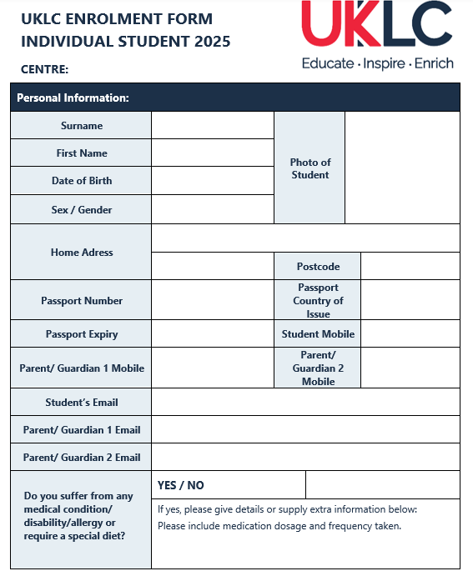
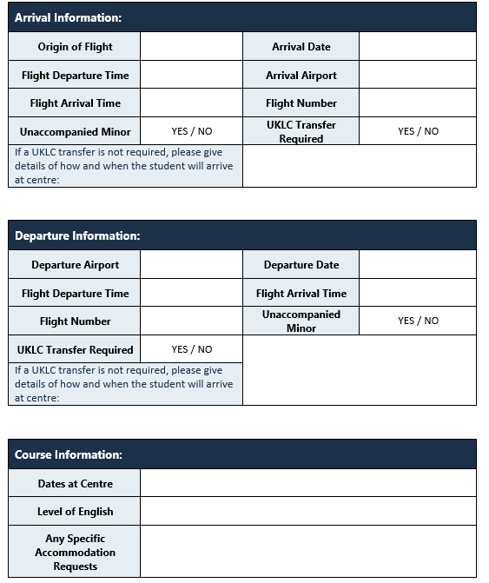
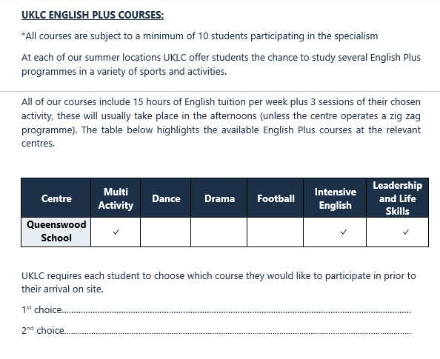
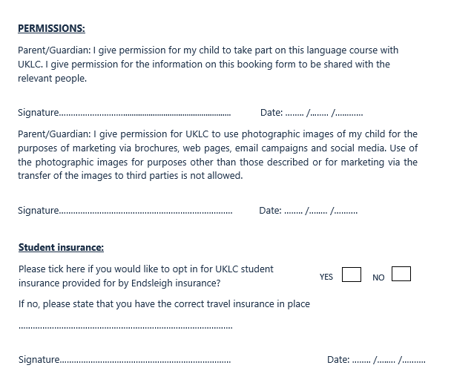

APPENDIX 5 – UKLC Enrolment Form / WASP Enrolment Form
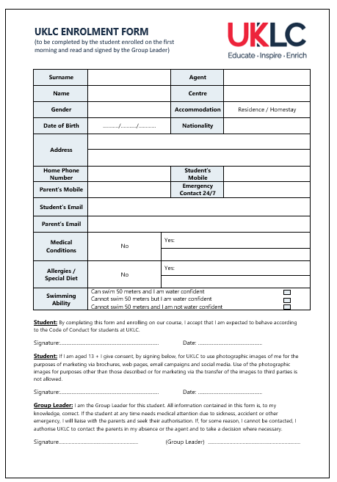
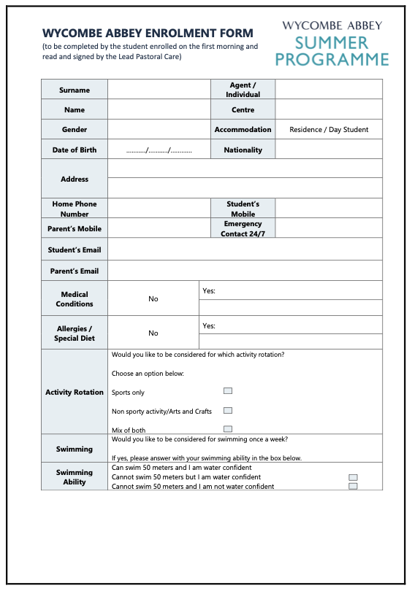

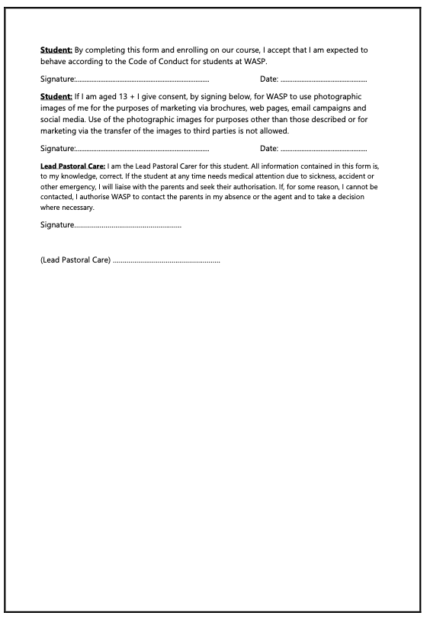

APPENDIX 6 - Code of Conduct for Students
BEHAVIOUR. Make your parents, teachers, group leaders and country proud!

TOLERANCE. In this school there are students from different countries and cultures. We're all different, and that's great!

RESPECT. Be nice to your friends, teachers and group leaders! Be polite, say "Please" and "Thank you".

SAFETY. Stay with your friends or your group. Wear your lanyard and wristband ALL THE TIME! (Every time you don't, you will pay £1)

HEALTH. Eat well, drink lots of water, wash your hands regularly, and get a good night’s sleep.

ENGLISH. You are here to learn English. Speak it as much as possible!

GET INVOLVED. There are many activities organised for you, join in and have fun!

TIME. Always be on time for lessons, activities and excursions.

INTERNET SAFETY. Do not give any personal information online. Protect your identity and do not speak to people you do not know in IRL (in real life!)

FEEDBACK. Tell us what you think. Your opinion is very important to us!

TRUST. If something is not right, tell us! Speak to your Group Leader or a member of the UKLC team

Your UKLC team (especially the SWC) are here to help you!

Extra for older students (14+)
We understand that some of you are more mature, and we respect that. However, you are still in our care, and we ask you to respect our code and behave just like when you are at home.

SMOKING. Please do not smoke indoors. You can only smoke outside in the designated areas.

DRUGS AND ALCOHOL. Please do not buy or consume alcohol or drugs.

NIGHTTIME. Please do not go into other people's bedrooms after 11 p.m.

STAY LEGAL! Please do not buy anything that is illegal or dangerous for you or other students.

THINK! Do not do anything that could be considered as bullying or sexual harassment: do not make unkind comments or inappropriate jokes, share pictures of other students, make unwanted physical gestures or make anyone feel uncomfortable.

PRIVACY. Do not give personal information to anyone you do not know.

APPENDIX 7 - Code of Conduct for Adults
We are committed to establishing an atmosphere of trust between the students in our care and all adults they come into contact with. This document describes the standards of conduct and practice that UKLC employees and group leaders should follow. Our aim is to protect all young people and adults connected with UKLC.

Terms
Young person: Any student or young person enrolled on a UKLC programme
Adult: Any UKLC team member, group leader, employee of hosting institution

- All students and adults must be treated with respect at ALL times.
- Working at a UKLC centre as a team member or a group leader means you have a duty of care towards the students, this is a legal obligation.
- You are in a position of trust, this cannot be abused*
- Be a good role model for the students, this means demonstrating integrity, maturity and good judgement.
- In all activities, UKLC team members and group leaders are required to be aware that physical contact with a young person may be misinterpreted. It is especially important to note the different cultures present at a UKLC centre. Whilst we understand that in some other cultures physical contact may be viewed differently, we ask all adults at our centres to understand that we are operating based on British culture and we expect them to as well.
- Any physical or manual touching required should be provided openly and if this is in a sporting situation, it should be in accordance with the guidelines provided by the appropriate National Governing Body.
- All adults are expected to dress appropriately at all times. For the UKLC team this means wearing their uniform when on duty, but for off duty team members and group leaders we would ask you to be considerate to the sensitive age of our students and any cultural sensitivities, avoid revealing too much flesh (low tops / shorts / miniskirts). This is especially important for residential staff in accommodation with students.
- In all lessons and activities, UKLC team members should recognise that special caution is required when discussing sensitive issues with young people.
- In all lessons and activities, feedback should be constructive rather than negative. Adults should not show favouritism or accept gifts (beyond limit) from students

In all dealings with young people, adults should never:
- play rough physical games or sexually provocative games
- share a room with a young person
- enter a young person’s room unless it is absolutely necessary and if entering a young person’s room,
do so accompanied
- allow or engage in any form of inappropriate touching
- be alone with a young person
- allow a young people to use inappropriate language without challenging it
- make sexually suggestive comments even in jest
- reduce a young person to tears as a form of control
- allow allegations made by a young person to go unchallenged, unrecorded or not acted upon

In all dealings with young people, adults must:
- set a good example by behaving appropriately at all times and maintaining professional boundaries
- ensure that their own behaviour is beyond reproach
- promote core British values
- be vigilant and act immediately if they become aware of any behaviour that gives cause for concern
- never access or share inappropriate sites, images or content at work
- avoid giving any personal contact details to young people, including their mobile number, home
phone, personal e-mail address, social media handles
- never accept requests from students via social media
- not use internet or web-based communication channels to send messages to students
- be sensible during any time off, especially with regards to socialising and alcohol consumption and especially when returning to sleep in accommodation where there are students lodged
*in accordance with latest legislation

Finally, all adults must understand their legal duty to voice any concerns. If this involves a child’s welfare or safety then you must speak up. Please understand that whether it concerns a colleague’s behaviour, a group leader’s behaviour or company policy, you may speak without fear of repercussions and in the knowledge that confidentiality will be maintained.

APPENDIX 8 – LADO and PREVENT contact details per centre
Centre | LADO name and address | LADO Phone number | LADO email | Prevent name and address | Prevent phone number | Prevent email
Bristol, Clifton College | Nicola Laird  BSCB Safeguarding (CH)  PO BOX 3176  Bristol  BS39FS | 0117 9037795 | nicola.laird@bristol.gov.uk | Police Prevent Team | 0800 789 321 | www.ireportit.uk
Chester, University of Chester | Cheshire west and Chester Safeguarding Children Partnership  The Portal, Wellington Road, Ellesmere Port, CH65 0BA | No direct number | Referrals to  Safeguardinglado@cheshirewestandchester.gov.uk | Cheshire constabulary | 01606362121 | prevent@cheshire.pnn.police.uk
Queen Mary’s University | Melanie Benzie  Mulberry Place  5 Clove Crescent  London  E14 2BG | 020 7364 0677  07903 238827 | LADO@towerhamlets.gov.uk | Tower Hamlets Prevent Team  160 Whitechapel Road  London  E1 1BJ | 020 7364 3009 | Mash@towerhamlets.gov.uk.
London, King’s College London | Southwark Council  PO BOX 64529  London SE1P 5LX | 020 7525 3297 | safeguardingchecks@southwark.gov.uk | Prevent Team at Southwark Council  160 Tooley Street, London SE1 2QH | 0800 011 3764 | prevent@southwark.gov.uk
York, Bootham & St Peter’s School | City of York Safeguarding Board  City of York Council  Station Rise, York, YO1 6GA | 01904 551783 | lado@york.gcsx.gov.uk | North Yorkshire Police Prevent Team | 01904 555742 | preventenquiries@york.gov.uk
Nantwich, Reaseheath College | Cheshire east and Chester Safeguarding Children | 01270685904 | LADO@cheshireeast.gov.uk | Lynsay Mullin | 01606 362121 | prevent@cheshire.pnn.police.uk.
Reading, Queen Anne’s School | Berkshire West Safeguarding Children Partnership | 01189372684 | LADO@brighterfuturesforchildren.org | Thames Valley Police | 08000113764 | preventreferralsreading@thamesvalley.pnn.police.uk
Winchester, St. Swithun’s | Hampshire County Council | 01962 876364 | Initial Form (HERE) | Hampshire Prevent Board | Adult: 0300 555 1386  Children: 0300 555 1384 | N/A  More info on website (HERE)
Portsmouth, University of Portsmouth | Portsmouth City Council | 023 9288 2500 | LADO@portsmouthcc.gov.uk | Portsmouth MASH Team | 0845 671 0271 | Mash@portsmouthcc.gov.uk
High Wycombe, Wycombe Abbey | Buckinghamshire Council | 01296 382070 | secure-LADO@buckinghamshire.gov.uk | Thames Valley Police | 08000113764 | preventreferralsreading@thamesvalley.pnn.police.uk
Cheltenham,  Dean Close School | Nigel Hatten, Gloucester County Council | 01452426994 | nigel.hatten@gloucestershire.gov.uk | Gloucestershire Police | 0800 011 3764 | prevent@gloucestershire.pnn.police.uk
Hatfield, Queenswood | Hertfordshire County Council | 0300 123 4043 | LADO.Referral@hertfordshire.gov.uk | Welwyn Hatfield Anti-Social Behaviour Team | 01707 357 000 | asb@welhat.gov.uk
Manchester, Chetham’s | Manchester Safeguarding Partnership | 0161 234 1214 | qualityassurance@manchester.gov.uk | Manchester Prevent Team | 0161 856 6362 | prevent@manchester.gov.uk

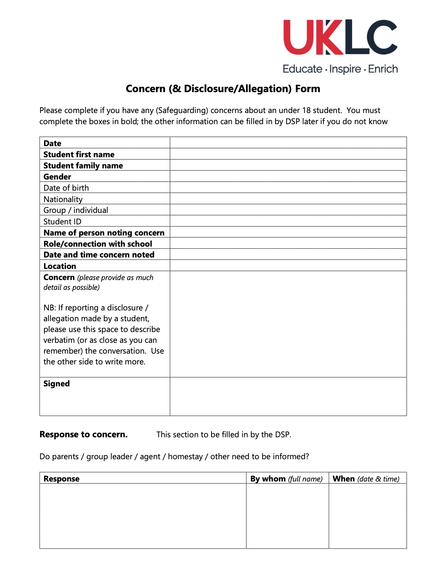
APPENDIX 9 – Concern/ Allegation Form

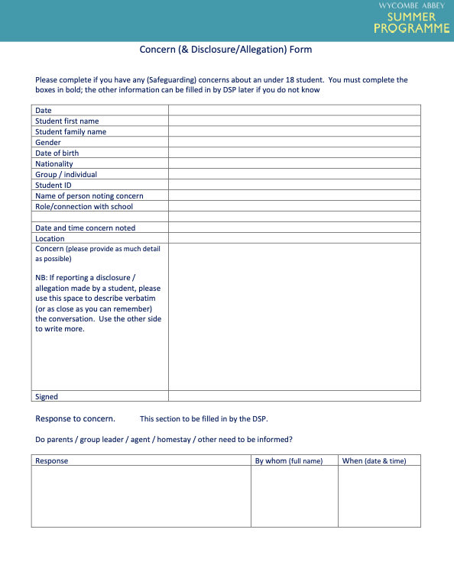

APPENDIX 10 – Prevent Form
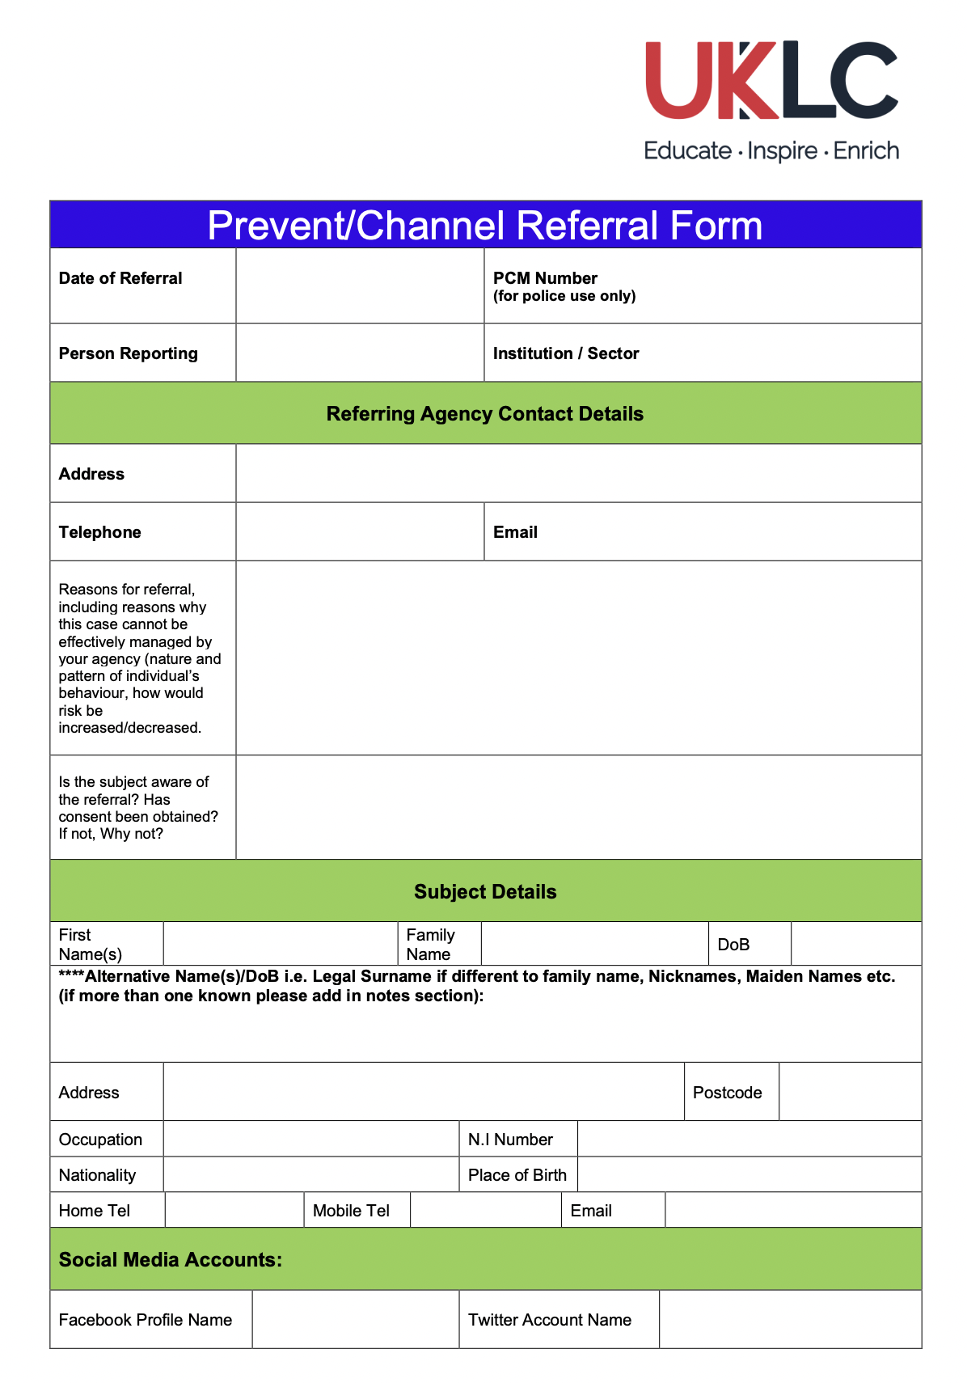

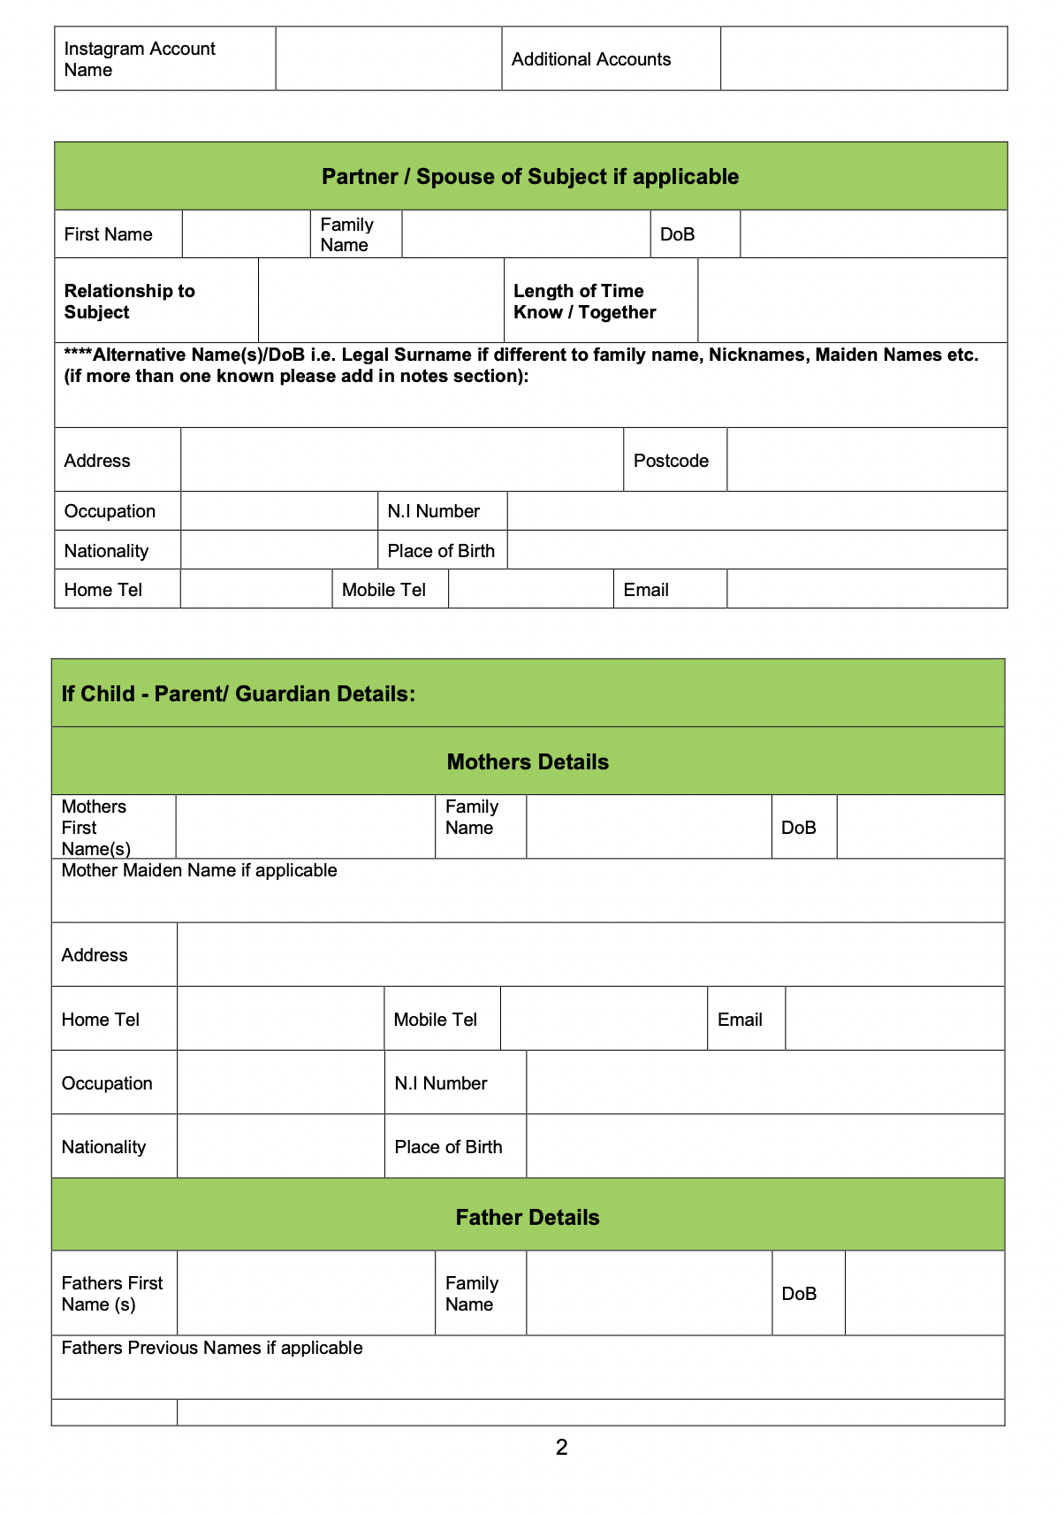
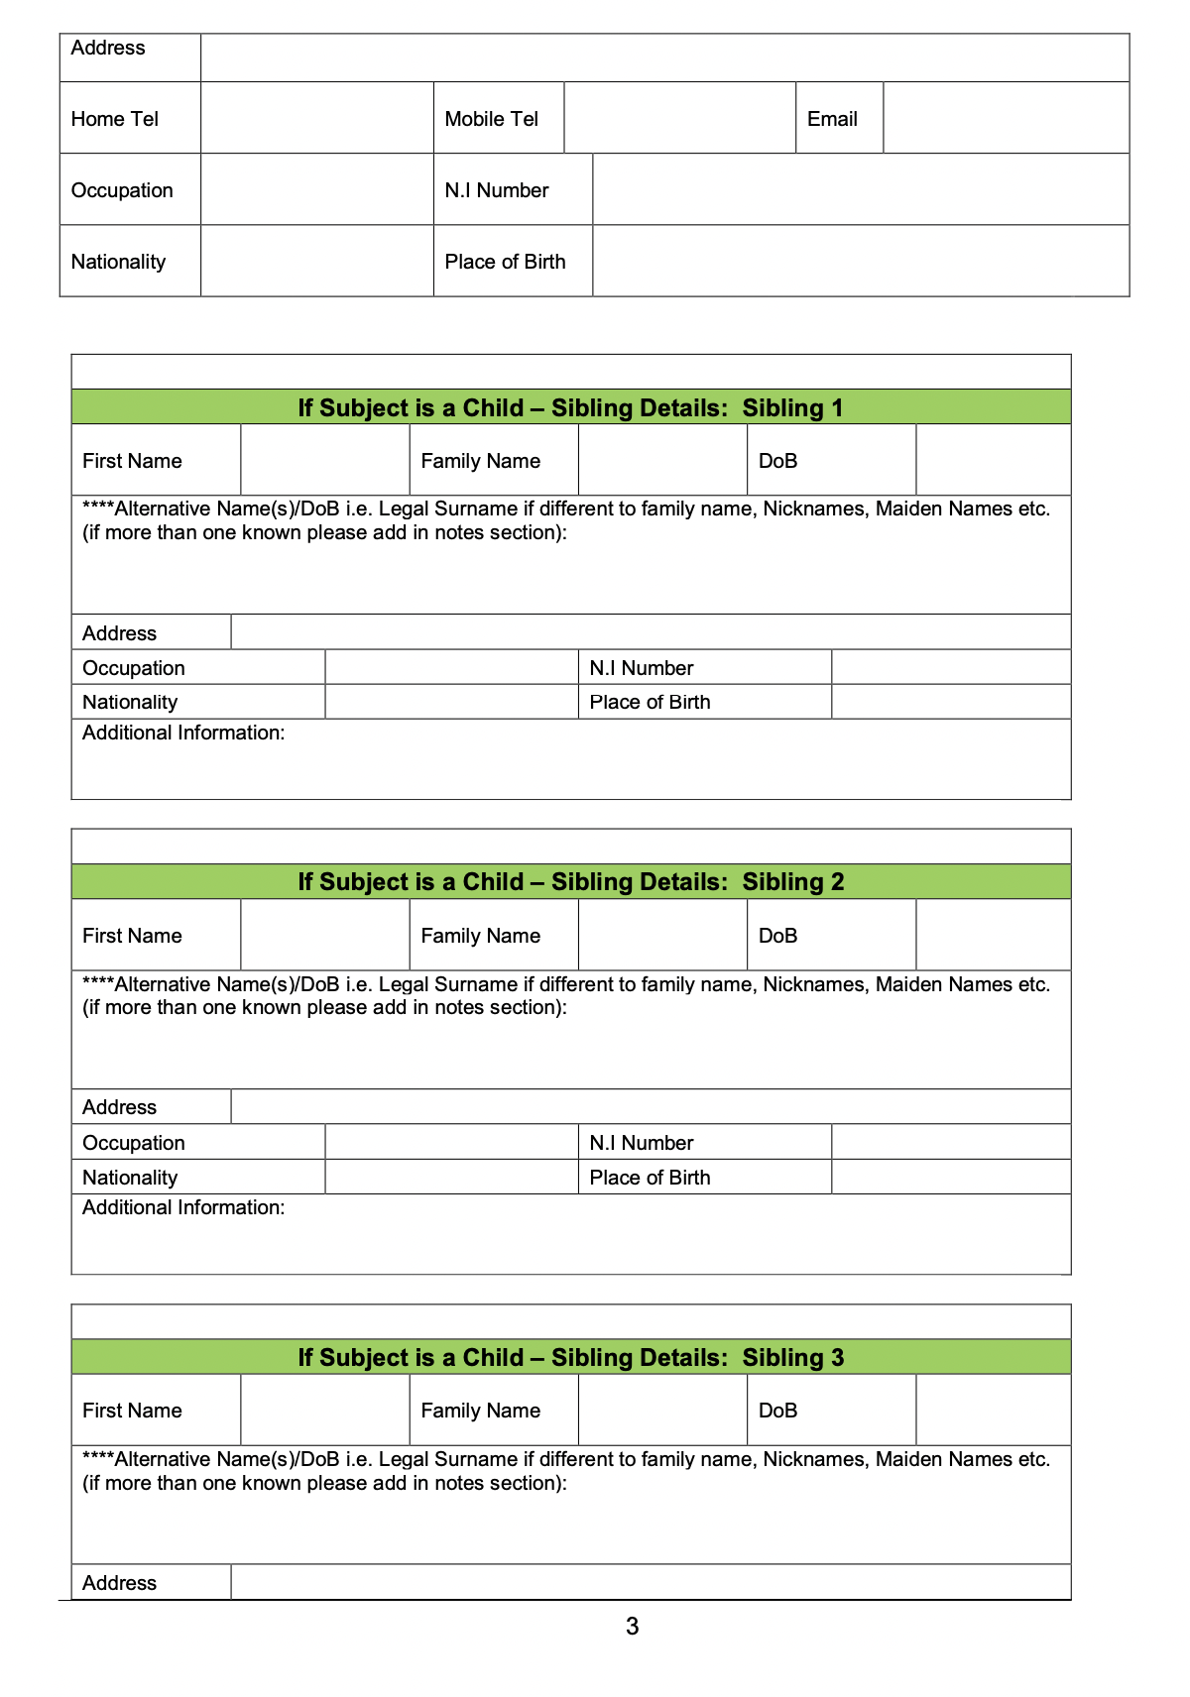
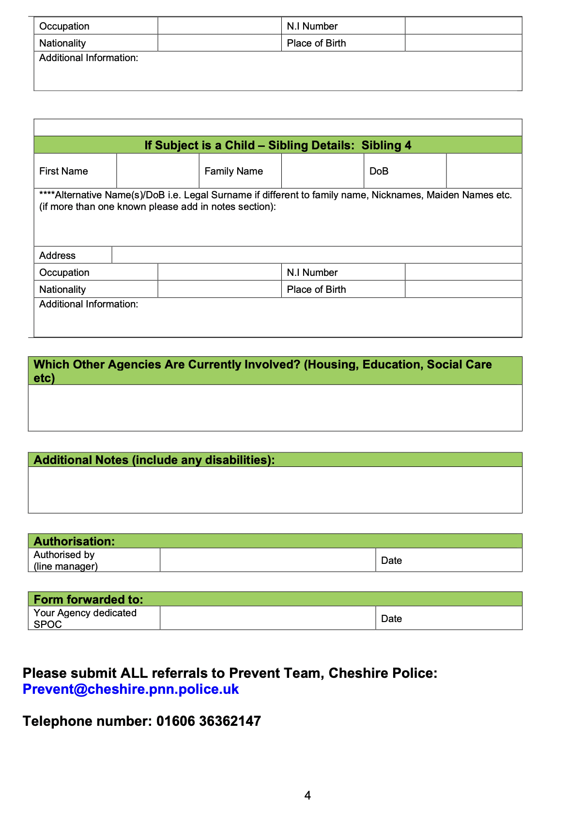


APPENDIX 11 - Centre Residential Group Checklist
The following checklist is designed to ensure that all information is covered in the welcome talk and the first group leader meeting. You must take the Group Leader through all the points and then ask them to sign that everything has been explained and that they have read and understood the handbook.

Issue | Comments | Covered

Welcome Talk with group
- Introduction to key UKLC Team
- Rules & regulations of Centre
- Damage deposits

Site Tour
- Fire Assembly Point
- Safety aspects of grounds
- Entrance to dining hall
- Areas out of bounds
- Security measures
- Swimming Pool usage / safety (if applicable)
- Correct routes around school
- Sports hall
- IT Info
Room Allocation done and accepted
Group Leader meeting:
Emergency Contact Numbers – given and mobile numbers exchanged
Accident / Incident procedure
Fire Lists (who is sleeping where)
First Aid Provision (where and who)
Fire Drill
Damage Inspection carried out
Catering Information
Dietary requirements including packed lunches, any allergies and/or any special requirements e.g. halal meat
Laundry
Group Leader Handbook – Responsibilities
All Enrolment forms signed off
Smoking regulations
Alcohol consumption
Students leaving site unaccompanied
Accommodation Keys & Codes
Arrange meeting times
Programme given and discussed
Initial feedback link given
Damage deposit money collected (if applicable) | Amount:
Final number of Students:
Final number of Group Leaders:
All aspects of the site have been discussed as noted above and I have attended the UKLC Group Leader training session and I have read and agree to adhere to the Code of Conduct for Adults.
Signed: Group leader Signed: Management Team
Name: Group leader Name: Management Team

APPENDIX 12 – First Aid Usage Form
FIRST AID USAGE FORM

The contents of each first aid kit are dependent on the size of the kit. A list of contents can be found inside each kit.

First Aid Kit Number. | Item Used. | No: Used. | Date Used. | Used by. (Initials) | Reason for Usage.

APPENDIX 13 – Incident Form
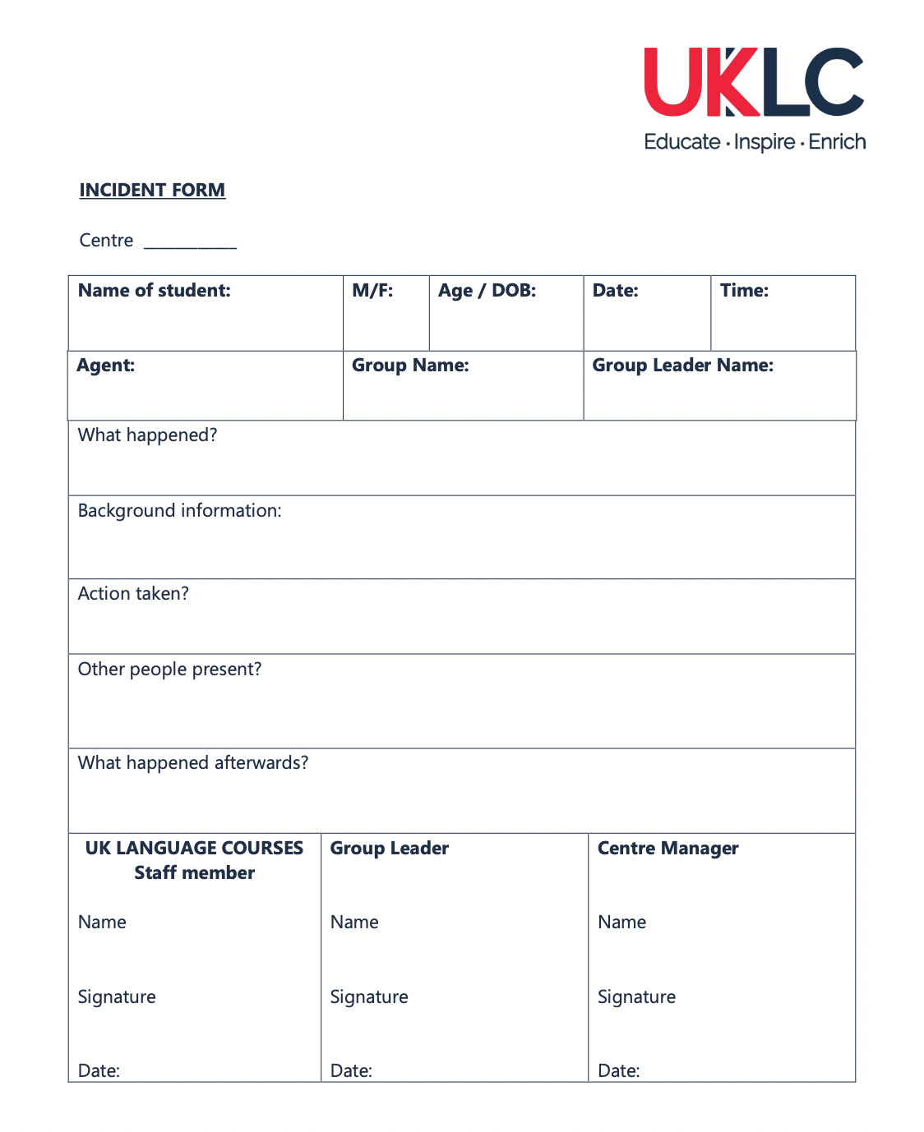

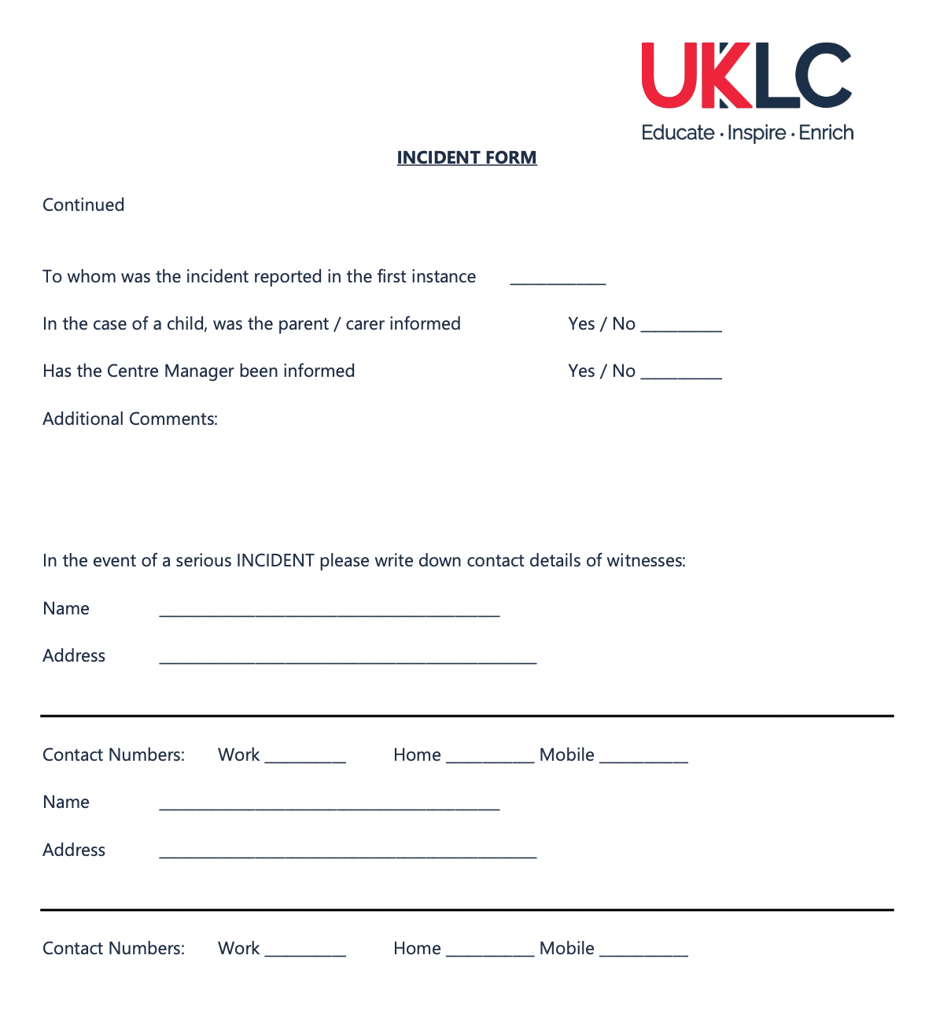
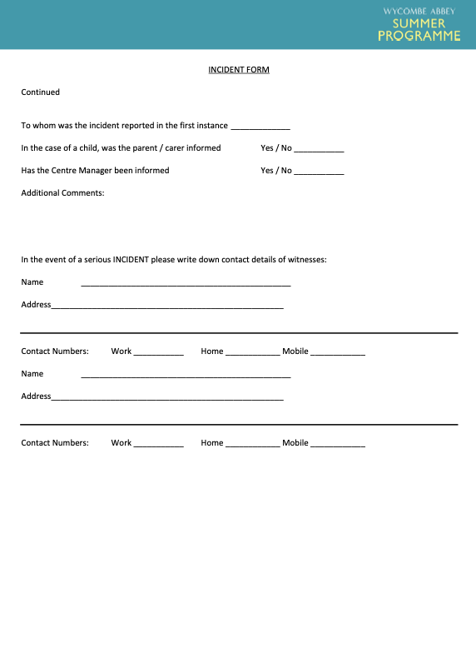

APPENDIX 14 – Accident Form
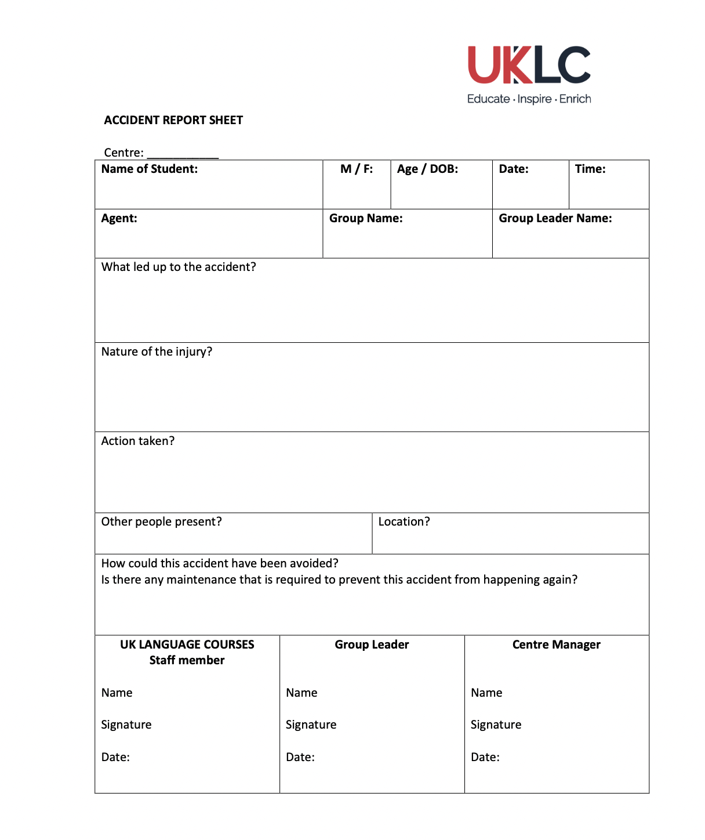
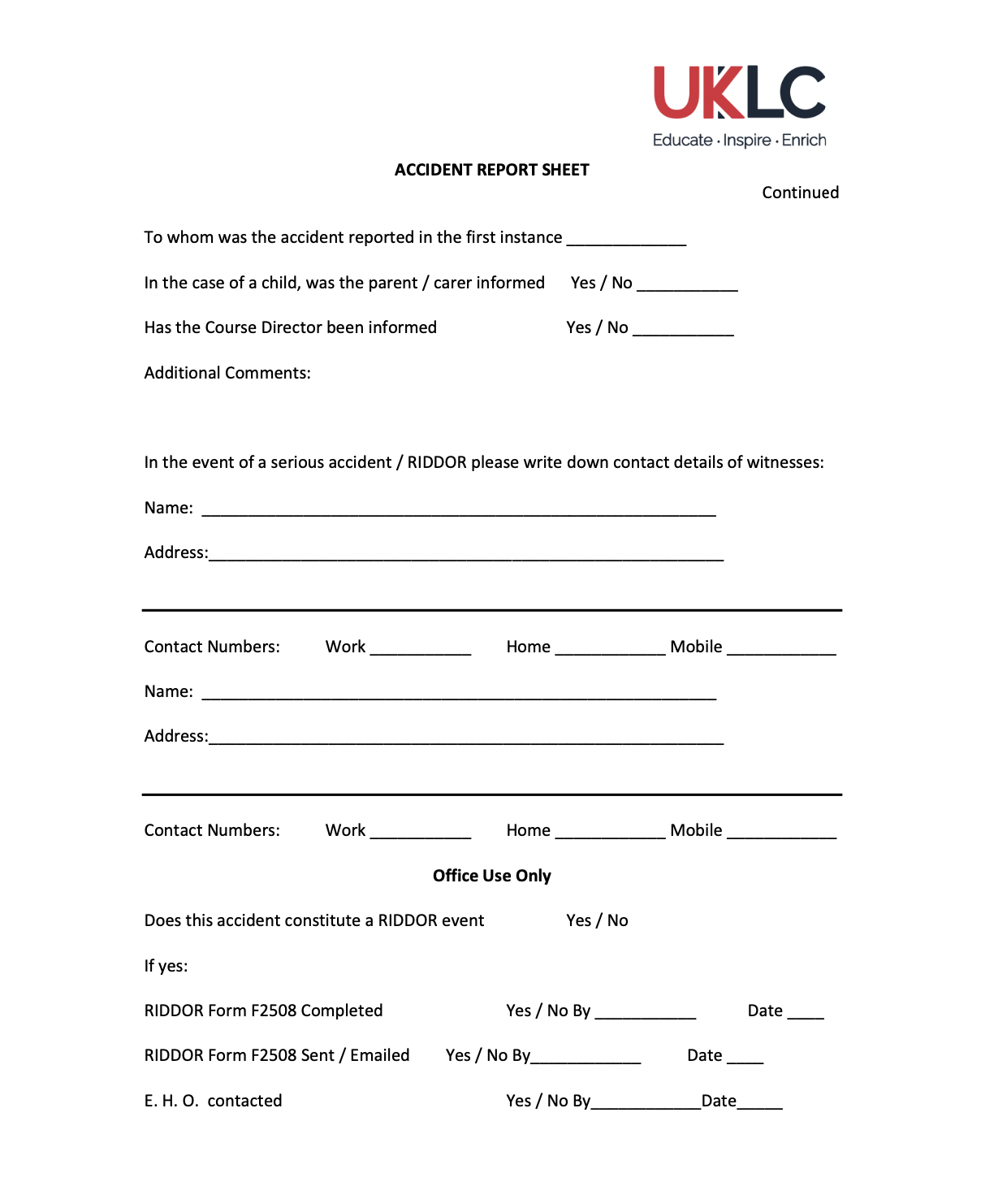

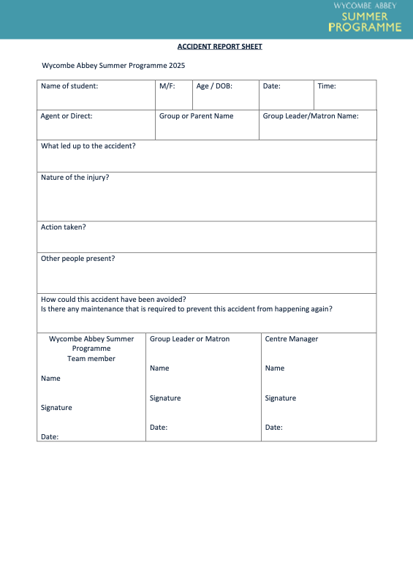

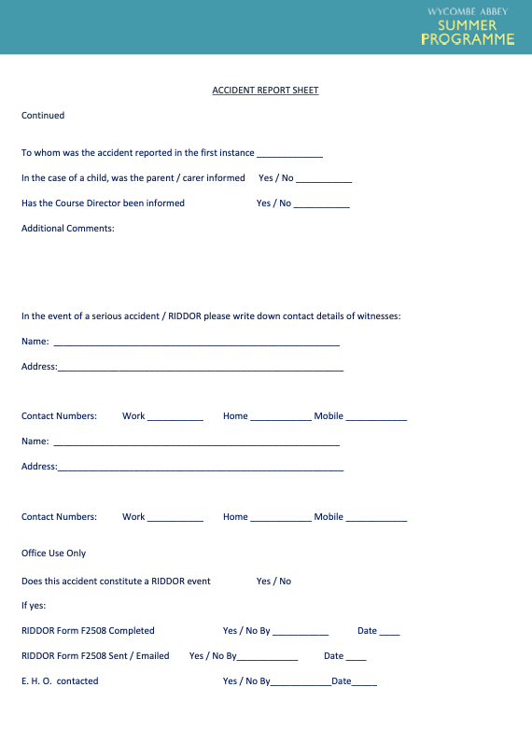

APPENDIX 15 - Fire Log Form

Centre ____________

Date:
Time:
How Long:
Who by:
Supervisors name:
Total amount of young people present:
Total amount of adults present:
Give any details of any problems or comments regarding the evacuation procedure:
Signed:
Dated:

UKLC, Suite 1D, Rossett Business Village, Rossett LL12 0AY
Telephone: 01244 577995 Fax: 01244 579136

APPENDIX 16 - Visitors Log
NAME | COMPANY / PLACE OF WORK | REASON FOR VISIT | DATE | TIME IN | TIME OUT | SIGNATURE OF VISITOR | UK LANUAGE COURSES TEAM MEMBER NAME & SIGNATURE

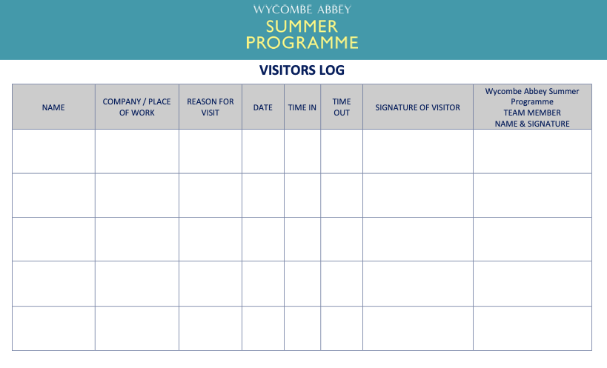

APPENDIX 17 - UKLC team excursion information sheet
(For ALL UKLC team members accompanying students on excursions)
For each excursion there will be a minimum of two members of the UKLC team per destination. One of these will be nominated as the Excursion Leader and will be responsible for communicating with the coach driver/s and Group Leaders. This involves arranging meeting points and pick up times, taking a register and liaising with Group Leaders to ensure that all students are present (with wristbands on) and have understood the various meeting points and times and informing the coach driver/s of any pickups and the final departure time.

The other UKLC team member will be responsible for ensuring that all students and Group Leaders have been given the relevant tourist information and any worksheets or maps. They will also deal with any museum bookings, tours or other entrances that have been organised for the day.

Checklist:
Do you have…
- Packed lunches (if required)
- First Aid Kits
- Hand sanitiser and anti-bacterial wipes
- Links for tourist info re the destination and the museum/attraction?
- A method of payment if one is required/ voucher / email of authorisation?
- Email confirming the booking with the relevant museum?
- The phone number of the coach company and of the driver?
- The phone number for your Centre Manager and Excursions and Activity Manager, your phone fully charged and the emergency mobile number?
- All students have their journals?
- Registers?

What to do if……

The venue you are visiting has no record of your booking.
It sometimes happens that the person you encounter in a museum or attraction will not be able to find the record of our booking. It may have been mislaid or entered in the wrong date. If you have a confirmation email this will usually solve the problem. If not, keep calm and try and resolve the situation amicably. You can ask the person to ring your Centre Manager or just see if there is another time that they can fit you in.

There has been a mix up regarding payment
Most attractions will usually count the students in and then send an invoice to us. However, sometimes one person will agree to invoice over the phone and then when you get to the reception you are asked to pay. Never pay out of your own money! At this point you need to contact the Senior Leadership Team to sort it out and give them the address to invoice:

UKLC Ltd, Unit 1d,
Rossett Business Village,
LL12 0AY

You have been delayed departing and you will arrive back at the centre later than planned.
You must inform the Centre Manager of any delay especially as it will probably affect dinner. Please do this as soon as you can to avoid any problems with food once you return to site.

You are at the coach at the arranged meeting time and one student fails to show.
On the coach before letting the students go anywhere you must brief all students on what to do if they get lost. As all students have phones, generally this is easily resolved with a phone call to locate them. However, if a student (miraculously) does not have a phone with them then they should try and find their way back to the meeting point and wait. Any Group Leader missing a student should always return to the meeting point to find them.

Stress to students that they should always have the 24hr emergency number with them (on their wristbands): 00 44 1244 567 695.

If the missing person(s) incident occurs in the morning or while visiting the first of two destinations in one day, the Excursion Leader should remain at the first destination and continue trying to find the student(s). If they turn up, all of you should make your way to the second destination to meet up with the rest of the group and the coach. If you will not make it to the other location before the scheduled departure time, call one of the other team members on the coach and arrange for the coach to come and pick you all up on the way back to the Centre.

Whatever happens, if a student is lost and you are being significantly delayed (over an hour), then you should leave an adult (either the Excursion Leader or another member of the team or a Group Leader if they speak good English and they have another leader / a member of the UKLC team to take over looking after the rest of their group) at the departure point. Make sure they have all phone numbers and enough money to get themselves and the student home, then accompany the rest of the group home.

On return to the Centre an Incident report Form should be completed. The Excursion Leader (and/or a member of SLT) should then liaise with the relevant Group Leader to notify the parent(s) of the missing student(s).

Depending on the extent to which missing the deadline was wilful, the student(s) participation in further excursions may be restricted. This will be evaluated by the SLT.

A member of the excursion is injured and has to go to Hospital:
If a student requires hospital treatment, a member of the UKLC team AND a relevant Group Leader should accompany the injured student to the hospital. The SLT must be notified too. The team member should ensure that they have a working mobile phone.

On return to site, an Incident report Form should be completed. The Excursion Leader (and/or a member of SLT) should then liaise with the relevant Group Leader to notify the parent(s) of the injured student(s) if this has not already been done. Please keep receipts for any expenses you may incur in order to travel back to the centre.

A student is arrested or detained by the Police (i.e., for shoplifting or a public disorder offence):
Depending on the time of the incident and the expected timescale involved for the Police to process the case, it may be necessary for the Excursion Leader to send the coach back to the Centre. The Group Leader should remain with the Excursion Leader to help with any translation issues. In the event that the student will not be released on the same day, the SLT must be contacted and the Group Leader should be liaised with in order to notify the parents.

On return to site, an Incident report Form should be completed.

The student(s) concerned may be sent home or banned from further excursions, depending on the severity of the offence.

There are not enough packed lunches.
This is a classic! The best thing is to check and double check before you get on the coach that you have enough lunches for the number of people on your coach. Never give the students the packed lunches before they get on the coach as they will just eat them and create mess. When you arrive at your destination, it is vital when giving out lunches that no one takes two. Obviously, this is difficult and so if you end up with some students who have no lunches, then you can tell them to go and spend up to £4 on lunch and keep their receipts. They will then be reimbursed by the Centre Manager when you return. Do not start giving out money; if they do not have any then they should borrow from their Group Leader. If you absolutely have to spend money, then get receipts! No money can be reimbursed without receipts.

For some reason a Group Leader decides that they don’t want to visit the museum that has been arranged
Sometimes the Group Leaders will try and take over the day. You must insist firmly but politely that everything has been booked and paid for in advance and that no changes can be made. If they are not satisfied with the visit, then they must speak to the Centre Manager when they get back. Remind them that they had time to talk to the Centre Manager before the excursion and should have asked for any changes to be made then.

It is a difficult juggling act. You must always be polite with Group Leaders and try to accommodate them as much as possible. After all, they are the client. However, you cannot let one Group Leader who is being particularly demanding ruin the day for everyone. Remember that there is always someone on the duty mobile or the Senior Leadership team can be contacted. If you are in a difficult situation, then ring and ask advice.

You feel that the students are at risk
Everyone’s awareness of risk is heightened today especially when European cities are vulnerable to terrorist attacks. If you feel that the students you are accompanying are at risk in any way then you must act. In stressful situations people will often panic and it is more frightening if you are in a foreign country. So, whether it be a group of drunken football fans who suddenly appear, or a bomb scare you must try as much as possible to take control of the situation. Walk the students towards the nearest public building and keep checking that they are all there. Call the police if you feel it is necessary and call the coach driver to come and pick you up. Please also call your Centre Manager immediately if you need advice. We expect our team to act with common sense and responsibility in the face of any risk to students.

A final note
On excursions your role is to guide and assist. You are not expected to be the fountain of all knowledge regarding the history and age of buildings etc., but you are not expected to say “I dunno, I’ve never been here before!” either. Members of the team who are not involved in teaching should also be familiar with what content has been covered in the lessons so that they are in a position to help students with any worksheets they may have. You will have plenty of opportunity to research the excursion beforehand and you will be responsible for the smooth running of the day.

Try to mix with the students as much as possible and talk to them about what they are seeing. Let them try their English out on you and answer their questions.

There will always be some free time on excursions where the groups go off to have a look around or go shopping and during this time you can relax and have a break. If however, there are younger students who need accompanying, then work out a rota between the team members of the excursion to make sure that the students are supervised but that everyone gets a break.

A final word on excursions. They can be the best times ever and the bits the students will really remember! However, they can also be a moment when things somehow seem to unravel and everyone arrives back at the centres feeling exhausted and annoyed. The Operations team at head office have spent months planning the excursions and writing the itineraries. However, there are always unforeseeable events when moving large numbers of people around during peak tourist season. You can really play your part by being prepared. Do some research, make sure you know where you are going and what the itinerary is. Find out which groups you are accompanying and introduce yourself to the leaders in advance of the excursion. If you take some responsibility for the day then things will work out much better and your Excursion and Activity manager will love you! Remember that there is always someone just a phone call away.

APPENDIX 18 - Complaints Form

Centre ____________ Group _____________

Name of Complainant: | M/F: | Date: | Time:
Nature of Complaint:

Action taken in Response to Complaint:

Outcome of Complaint investigation:

Information given to Complainant:

Date Information Provided:

By:

Status:

APPENDIX 19 - Recruitment Policy
We aim to recruit suitably qualified people with relevant experience and loads of enthusiasm where possible.

As a mainly seasonal business running short courses, most of our teams are recruited on a temporary basis. In the interests of continuity, it is our policy to give preference wherever possible to returning team members. We feel that the more people who return to work again, the easier the set-up period is and the more smoothly our courses will run. This also offers us the opportunity to develop people and allow them to see progress and growth. Therefore, any satisfactory member of a team who wishes to return to work with us will be given preference with regards to location or length of contract.

We recruit people based on their suitability and ability to do the job. We aim to recruit people who are enthusiastic, motivated, appropriately qualified and above all else are keen to work with children. We require them to understand the importance of safeguarding in our organisation and how promoting the welfare of young people in our centres is a high priority.

We are committed to promoting equal opportunities in employment. Our employees and any job applicants will receive equal treatment regardless of age, disability, gender reassignment, marital or civil partner status, pregnancy or maternity, race, colour, nationality, ethnic or national origin, religion or belief, sex or sexual orientation. It applies to all aspects of employment with us, including recruitment. Please see our Diversity, Equity and Inclusion policy for further details.

RECRUITMENT PROCEDURE (for temporary positions)

- Applicants forward a copy of their full curriculum vitae (CV) or make an enquiry. These enquiries are made either directly to our email inbox or through another platform like Indeed.
Once we receive their CV, they are sent an application pack including our Working With Us document, our Diversity, Equity and Inclusion Policy, our Sexual Harassment Policy, our Anti-Harassment and Bullying Policy as well as the relevant job description. The application pack provides information about UKLC, our mission statement, our programmes and centres, the positions available with an overview of each role, our safeguarding and Child Protection Statement and a declaration of suitability to work with young people. An application form must be completed by every candidate.
In this application pack, candidates are sent a link to our online application form which is completed via Recruiterflow. On submission of their application form, candidates automatically have a Recruiterflow profile created for them.
- Candidates are then short-listed against a set of criteria depending on the position they are applying for.
- Suitable candidates are invited for an interview (usually via zoom) conducted by a member of the recruitment or academic team. (Interview guidance notes in Appendix 1)
- If the candidate is deemed suitable after the interview, then a provisional offer is sent by email and two written references (one of which will be followed up with a telephone call) will be sought. Where possible, one reference should apply to regulated activity with under 18s.
- Candidates are then asked to complete an online form to enable an Enhanced DBS check to be done unless they are already registered with the DBS Update Service. Team members holding Qualified Teacher Status will be checked against the Prohibited List with their permission. They are also invited to complete an online Safeguarding In Language Centres course and submit the certificate to head office. Candidates are also asked to complete an online Prevent course. Candidates who have lived or worked overseas for more than six months in the last five years will be required to provide an official Police check and accredited translation from the relevant country/countries. Where the Police check is not possible, we will collect two additional references from people who have seen the applicant working with under 18s. Candidates for management positions will also be requested to complete a Child Mental Health Awareness training and submit the certificate to head office. The submission of all documents will be via a link that uploads the documents directly to the candidate’s Recruiterflow profile.
- Once the references have been received and all checks completed and are satisfactory, a contract will be sent. The candidate is required to sign and return the contract and to complete a Team Information Form (TIF).

(All successful candidates will be asked if they have any special requirements for the assessment process and whether any reasonable adjustments need to be made.)

RECRUITMENT PROCEDURE (for returning temporary team members)

- Subject to giving their consent for their details to be held by us for possible future work, following the annual recruitment review in which their performance is evaluated, anyone who has been deemed acceptable for reemployment is contacted and asked if they wish to return. If so, they are asked to forward an up-to-date copy of their CV as well as completing a new application form via Recruiterflow. This includes a declaration of suitability to work with young people as well as the documents and policies sent to new team members.
- As all returners will have previously had an Enhanced DBS check carried out by UKLC, we would consider this valid for a period of three years. For anyone who has previously been DBS checked by UKLC and has registered with the update service, we will carry out the instant check to ensure that the information is up-to-date. If they have a more recent Enhanced DBS from another company (from the previous three months), we will ask to see it, make a note of the certificate number and accept it. Those holding Qualified Teacher Status will be checked against the Prohibited List with their permission. Candidates who have lived or worked overseas for more than six months in the last five years will be required to provide an official Police check and accredited translation from the relevant country/countries. Where the Police check is not possible, we will collect two additional references from people who have seen the applicant working with under 18s.
- In all cases, if returners have not worked for UKLC for over a three-month period, they will be asked to provide the details of their most recent employer who will be contacted in order to confirm their continued suitability to work with young people.
- All applicants are invited to complete an online Safeguarding in Language Centres and Prevent course and submit the certificates to head office. Candidates for management positions will also be requested to complete a Child Mental Health Awareness training and submit the certificate to head office. The submission of all documents will be via a link that uploads the documents directly to the candidate’s Recruiterflow profile.
- Once the references have been received and all checks have been returned as satisfactory, an offer email will be sent and a contract and the applicant is required to accept in writing and to complete a Team Information Form (TIF).

RECRUITMENT PROCEDURE (for permanent team members)
- Applicants forward a copy of their full curriculum vitae (CV). Suitable candidates are sent further information about the company and the position available and the relevant job description.
- Candidates are then short-listed against a set of criteria depending on the position they are applying for.
- Suitable candidates are invited to a face-to-face interview at our head office. The interview panel will include at least one Director and members of the Senior Leadership Team.
- Depending on the position, a second interview may be deemed necessary.
- If the Directors / SLT agree to a position being offered, two references will be sought and an offer made subject to satisfactory references. An Enhanced DBS check will also be carried out.
- Once the references have been received and are satisfactory, an offer letter will be sent and the candidate is required to accept in writing and to complete a Team Information Form (TIF) and relevant tax form.

(All successful candidates will be asked if they have any special requirements for the assessment process and whether any reasonable adjustments need to be made.)

Seasonal employees are put on 2-week probation (if appropriate), permanent employees on 6-month probation period. Please see our Culture Book and Employee Handbook for more details and policies.

Paperwork required:
- Full up to date CV
- Completed and signed application form
- Two referees who are not relatives. One referee must be from the person’s most recent employment. One should preferably in a role where they had access to or responsibility for children.
- Copies of all relevant qualifications (originals to be seen and scanned)
- Proof of Identity – passport, driving licence, birth certificate – one of which must have a photograph
- Evidence of right to work in the UK (this must be produced by all successful candidates). Please see Appendix 2
- Team Information Form including their next of kin details and any relevant medical information
- Candidates must notify the company of any changes/updates with their qualifications
- Appropriate security checks to be done which may take the form of an Enhanced Disclosure

Failure to complete the above can result in our offer of employment being withdrawn.

Interview Guidance Notes
- DO ensure the recruitment and selection process is as transparent and free from bias
- DO ensure recruitment files remain confidential
- DO shortlist candidates on the basis of objective criteria only
- DO follow an agreed set of questions for each candidate.
- DO feel free to ask supplementary questions depending on candidates answers
- DO keep written records throughout the process
- DO give unsuccessful candidates the opportunity to seek feedback as to why they were unsuccessful
- DON’T unlawfully discriminate in any way at any stage of the process (e.g. discriminate on the basis of age, disability, gender reassignment, marital or civil partner status, pregnancy or maternity, race, colour, nationality, ethnic or national origin, religion or belief, sex or sexual orientation)
- DON’T ignore a disability or medical condition:- If a candidate is disabled, the business has a duty to make reasonable adjustments. The employer must give the applicant an opportunity to suggest reasonable adjustments for the interview (e.g. leave more time for replies from an applicant with a hearing impairment).
- An employer should only ask about a disability if it is, or may be, relevant to the job after a reasonable adjustment. Above all, an employer must not ask discriminatory questions. All questions should relate directly to the job and the competencies required for the job.
- DON’T rely solely on word of mouth or recommendation for recruitment.

Documentation Checks
We will use the government guide below to ascertain the right to work of all employees.
https://www.gov.uk/government/publications/right-to-work-checks-employers-guide/an-employers-guide-to-right-to-work-checks-17-january-2022-accessible-version#introduction

- It is a requirement of the law on preventing illegal working that all employers make certain document checks. Home Office guidance and the Commission for Racial Equality Code of Practice recommend this is carried out for every prospective employee. Failure to undertake such a check, if the individual is subsequently found not to have the right to work in the United Kingdom, is a criminal offence.

- Employers have a statutory defence against conviction for employing an illegal worker if they check and copy certain original documents belonging to the individual before they commence employment. This will be done by the Manager when the job offer is made. The copies will be placed in the individual’s personal file.

- There are 3 steps to conducting a manual document-based right to work check. We will need to complete all 3 steps before employment commences to ensure we have conducted a check in the prescribed manner, in order to establish a statutory excuse. The details of the 3 steps process that we will follow is detailed here.

APPENDIX 20 Wycombe Abbey Summer Programmes Booking Forms
- Agent Booking Form: click HERE

- Direct booking form: click HERE

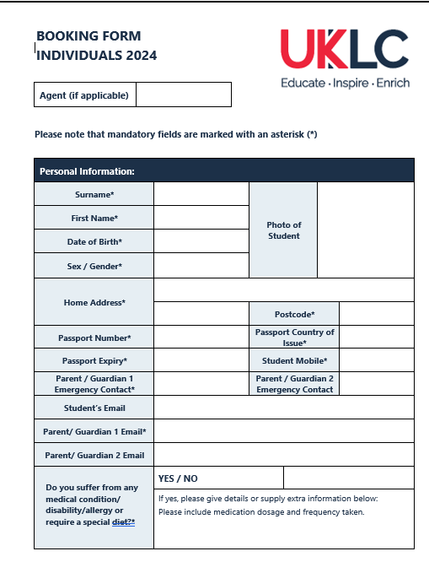

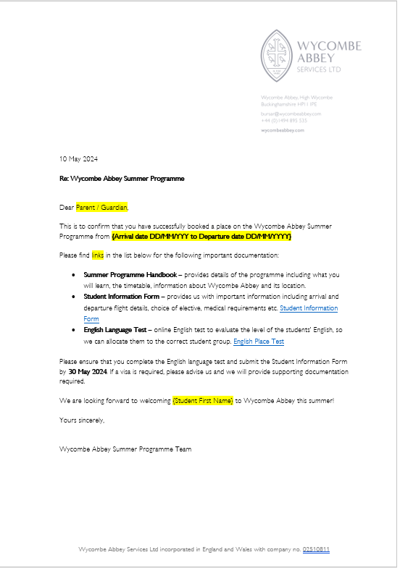
APPENDIX 21 Wycombe Abbey Summer Programmes Confirmation Letter

APPENDIX 22 Anti-Harassment and Bullying Policy
1. About this policy
1.1 We are committed to providing a working environment free from harassment and bullying and ensuring all employees are treated, and treat others, with dignity and respect.
1.2 This policy covers harassment or bullying which occurs at work and out of the workplace, such as on business trips or at work-related events or social functions. It covers bullying and harassment by employees (which may include consultants, contractors and agency workers) and also by third parties such as customers, suppliers or visitors to our premises. We have a separate policy dealing with sexual harassment.
1.3 This policy does not form part of any employee's contract of employment and we may amend it at any time. This policy replaces any previous anti-harassment and bullying policy previously issued.
2. What is harassment?
2.1 Harassment is any unwanted physical, verbal or non-verbal conduct that has the purpose or effect of violating a person's dignity or creating an intimidating, hostile, degrading, humiliating or offensive environment for them. A single incident can amount to harassment.
2.2 It also includes treating someone less favourably because they have submitted or refused to submit to such behaviour in the past.
2.3 Unlawful harassment may involve conduct of a sexual nature (sexual harassment), or it may be related to age, disability, gender reassignment, marital or civil partner status, pregnancy or maternity, race, colour, nationality, ethnic or national origin, religion or belief, sex or sexual orientation. Sexual harassment is dealt with under our separate policy. Harassment is unacceptable even if it does not fall within any of these categories.
2.4 Harassment may include, for example:
(a) offensive emails, text messages or social media content;
(b) derogatory or stereotypical remarks about a particular ethnic or religious group, religion or belief, or gender;
(c) mocking, mimicking or belittling a person's disability;
(d) unwanted physical conduct or "horseplay", including touching, pinching, pushing and grabbing; or
(e) unwelcome sexual advances or suggestive behaviour (which the harasser may perceive as harmless).
2.5 A person may be harassed even if they were not the intended "target". For example, a person may be harassed by racist jokes about a different ethnic group if the jokes create an offensive environment.
2.6 Victimisation includes subjecting a person to a detriment because they have done, or are suspected of doing or intending to do, any of the following protected acts:
(a) Bringing proceedings under the Equality Act 2010.
(b) Giving evidence or information in connection with proceedings under the Equality Act 2010.
(c) Doing any other thing for the purposes of or in connection with the Equality Act 2010.
(d) Alleging that a person has contravened the Equality Act 2010.
2.7 Victimisation may include, for example:
(a) Denying someone an opportunity because it is suspected that they intend to make a complaint about harassment.
(b) Excluding someone because they have raised a grievance about harassment.
(c) Failing to promote someone because they accompanied another employee to a grievance meeting.
(d) Dismissing someone because they gave evidence on behalf of another employee at an employment tribunal hearing.
2.8 Harassment and victimisation are unlawful and will not be tolerated. They may lead to disciplinary action up to and including dismissal.
2.9 Third-party harassment occurs where a person is harassed by someone who does not work for, and who is not an agent of, the same employer, but with whom they have come into contact during the course of their employment. Third-party harassment could include, for example, derogatory comments about a person's age, disability, colour or sexual orientation by a client, customer or supplier visiting the employer's premises, or where a person is visiting a client, customer or supplier's premises or other location in the course of their employment.

3. What is bullying?
3.1 Bullying is offensive, intimidating, malicious or insulting behaviour involving the misuse of power that can make a person feel vulnerable, upset, humiliated, undermined or threatened. Power does not always mean being in a position of authority, but can include both personal strength and the power to coerce through fear or intimidation.
3.2 Bullying can take the form of physical, verbal and non-verbal conduct. Bullying may include, for example:
(a) physical or psychological threats;
(b) overbearing and intimidating levels of supervision; or
(c) inappropriate derogatory remarks about someone's performance.
3.3 Legitimate, reasonable and constructive criticism of a worker's performance or behaviour, or reasonable instructions given to workers in the course of their employment, will not amount to bullying on their own.
4. If you are being harassed or bullied
4.1 If you are being harassed or bullied, consider whether you feel able to raise the problem informally with the person responsible. You should explain clearly to them that their behaviour is not welcome or makes you uncomfortable. If this is too difficult or embarrassing, you should speak to your manager, who can provide confidential advice and assistance in resolving the issue formally or informally.
4.2 If informal steps are not appropriate, or have not been successful, you should raise the matter formally under our Grievance Procedure.
4.3 We will investigate complaints in a timely and confidential manner. The investigation will be conducted by someone with no prior involvement in the complaint, where possible. Details of the investigation and the names of the person making the complaint and the person accused must only be disclosed on a "need to know" basis. We will consider whether any steps are necessary to manage any ongoing relationship between you and the person accused during the investigation.
4.4 Once the investigation is complete, we will inform you of our decision. If we consider you have been harassed or bullied by an employee the matter will be dealt with under the Disciplinary Procedure as a case of possible misconduct or gross misconduct. If the harasser or bully is a third party such as a customer or other visitor, we will consider what action would be appropriate to deal with the problem. Whether or not your complaint is upheld, we will consider how best to manage any ongoing working relationship between you and the person concerned.
5. Protection and support for those involved
5.1 Employees who make complaints, report that they have witnessed wrongdoing, or who participate in good faith in any investigation must not suffer any form of retaliation or victimisation as a result. Anyone found to have retaliated against or victimised someone in this way will be subject to disciplinary action under our Disciplinary Procedure.
6. Record-keeping
6.1 Information about a complaint by or about an employee may be placed on the employee's personnel file, along with a record of the outcome and of any notes or other documents compiled during the process.

APPENDIX 23 Sexual Harassment Policy
1. Policy statement
1.1 We are committed to providing a working environment free from sexual harassment and ensuring all employees are treated, and treat others, with dignity and respect. We recognise that sexual harassment can occur both in and outside the workplace, such as on business trips, or at work-related events or social functions, or on social media.
1.2 Sexual harassment or victimisation of any member employee, or anyone they come into contact with during the course of their work, is unlawful and will not be tolerated. We will take active steps to help prevent the sexual harassment and victimisation of all employees. Anyone who is a victim of, or witness to, sexual harassment is encouraged to report it in accordance with this policy. This will enable us to take appropriate action and provide support. Sexual harassment can result in legal liability for both the business and the perpetrator, whether they work for us or are a third party outside of our control. Sexual harassment may result in disciplinary action up to and including dismissal.
2. About this policy
2.1 The purpose of this policy is to set out a framework for managers to deal with any sexual harassment that occurs by employees (which may include consultants, contractors and agency workers) and also by third parties such as customers, suppliers or visitors to our premises.
2.2 This policy does not form part of any contract of employment or contract to provide services, and we may amend it at any time.
3. What is sexual harassment?
3.1 Sexual harassment is any unwanted physical, verbal or non-verbal conduct of a sexual nature that has the purpose or effect of violating a person's dignity, or creating an intimidating, hostile, degrading, humiliating or offensive environment for them. A single incident can amount to sexual harassment.
3.2 It also includes treating someone less favourably because they have submitted or refused to submit to unwanted conduct of a sexual nature, or that is related to gender reassignment or sex, in the past.
3.3 Sexual harassment may include, for example:
(a) unwanted physical conduct or "horseplay", including touching, pinching, pushing and grabbing;
(b) continued suggestions for sexual activity after it has been made clear that such suggestions are unwelcome;
(c) sending or displaying material that is pornographic or that some people may find offensive (including emails, text messages, video clips and images sent by mobile phone or posted on the internet);
(d) unwelcome sexual advances or suggestive behaviour (which the harasser may perceive as harmless); or
(e) offensive emails, text messages or social media content.
3.4 A person may be sexually harassed even if they were not the intended target. For example, a person may be sexually harassed by pornographic images displayed on a colleague's computer in the workplace.
3.5 Victimisation includes subjecting a person to a detriment because they have done, or are suspected of doing or intending to do, any of the following protected acts:
(a) Bringing proceedings under the Equality Act 2010.
(b) Giving evidence or information in connection with proceedings under the Equality Act 2010.
(c) Doing any other thing for the purposes of or in connection with the Equality Act 2010.
(d) Alleging that a person has contravened the Equality Act 2010.
3.6 Victimisation may include, for example:
(a) Denying someone an opportunity because it is suspected that they intend to make a complaint about sexual harassment.
(b) Excluding someone because they have raised a grievance about sexual harassment.
(c) Failing to promote someone because they accompanied another employee member to a grievance meeting.
(d) Dismissing someone because they gave evidence on behalf of another employee member at an employment tribunal hearing.
3.7 Sexual harassment and victimisation are unlawful and will not be tolerated. They may lead to disciplinary action up to and including dismissal if they are committed:
(a) In a work situation.
(b) During any situation related to work, such as at a social event with colleagues.
(c) Against a colleague or other person connected to us outside of a work situation, including on social media.
(d) Against anyone outside of a work situation where the incident is relevant to your suitability to carry out your role.
3.8 We will take into account any aggravating factors, such as abuse of power over a more junior colleague, when deciding the appropriate disciplinary action to take.
3.9 If any sexual harassment or victimisation of employees occurs, we will take steps to remedy any complaints and to prevent it happening again. These may include updating relevant policies, providing further employee training and taking disciplinary action against the perpetrator.
3.10 Third-party harassment occurs where a person is harassed or sexually harassed by someone who does not work for, and who is not an agent of, the same employer, but with whom they have come into contact during the course of their employment. Third-party harassment could include, for example, unwelcome sexual advances from a client, customer or supplier visiting the employer's premises, or where a person is visiting a client, customer or supplier's premises or other location in the course of their employment.
3.11 Third-party sexual harassment can result in legal liability and will not be tolerated. All employees are encouraged to report any third-party harassment they are a victim of, or witness, in accordance with this policy.
3.12 Any sexual harassment by an employee against a third party may lead to disciplinary action up to and including dismissal.
3.13 We will take active steps to try to prevent third-party sexual harassment of employees.
3.14 If any third-party harassment of an employee occurs, we will take steps to remedy any complaints and to prevent it happening again.
4. If you are being sexually harassed: informal steps
4.1 If you are being sexually harassed, consider whether you feel able to raise the problem informally with the person responsible. You should explain clearly to them that their behaviour is not welcome or makes you uncomfortable. If this is too difficult, you should speak to your manager, who can provide confidential advice and assistance in resolving the issue formally or informally. If you feel unable to speak to your manager because the complaint concerns them, you should speak informally to a senior manager, director or if we have one the HR team. If this does not resolve the issue, you should follow the formal Grievance Procedure below.
4.2 If you are not certain whether an incident or series of incidents amounts to sexual harassment, you should initially contact your manager informally for confidential advice.
4.3 If informal steps are not appropriate, or have been unsuccessful, you should refer to our Grievance Procedure.
5. Raising a formal complaint
5.1 If you wish to make a formal complaint about sexual harassment, you should refer to our Grievance Procedure.
5.2 Your written complaint should set out full details of the conduct in question, including the name of the harasser, the nature of the sexual harassment, the date(s) and time(s) at which it occurred, the names of any witnesses and any action that has been taken so far to attempt to stop it from occurring.
5.3 If you wish to make a formal complaint about victimisation, you should you should refer to our Grievance Procedure.
5.4 Your written complaint should set out full details of the conduct in question, including the name of the person or persons you believe have victimised you, the reason you believe you have been victimised, the nature of the victimisation, the date(s) and time(s) at which it occurred, the names of any witnesses and any action that has been taken so far to attempt to stop it from occurring.
5.5 As a general principle, the decision whether to progress a complaint is up to you. However, we have a duty to protect all employees and may pursue the matter independently if, in all the circumstances, we consider it appropriate to do so.
6. If you witness sexual harassment or victimisation
6.1 Employees who witness sexual harassment or victimisation are encouraged to take appropriate steps to address it. Depending on the circumstances, this could include:
(a) Intervening where you feel able to do so.
(b) Supporting the victim to report it or reporting it on their behalf.
(c) Reporting the incident where you feel there may be a continuing risk if you do not report it.
(d) Co-operating in any investigation into the incident.
6.2 All witnesses will be provided with appropriate support and will be protected from victimisation.
7. Formal investigations
7.1 We will investigate complaints in accordance with our Grievance Procedure and do so in a timely, respectful and confidential manner. Individuals not involved in the complaint or the investigation should not be told about it.
7.2 We will arrange a meeting with you, so that you can give your account of events. You have the right to be accompanied by a colleague or a trade union representative of your choice, who must respect the confidentiality of the investigation.
7.3 Where your complaint is about an employee, we may consider suspending them on full pay or making other temporary changes to working arrangements pending the outcome of the investigation, if circumstances require. The investigator will also meet with the alleged harasser to hear their account of events. They have a right to be told the details of the allegations against them, so that they can respond.
7.4 Where your complaint is about someone other than an employee, such as a customer, supplier or visitor, we will consider what action may be appropriate to protect you and anyone involved pending the outcome of the investigation, bearing in mind the reasonable needs of the business and the rights of that person. Where appropriate, we will attempt to discuss the matter with the third party.
7.5 We will also consider any request that you make for changes to your own working arrangements during the investigation. For example, you may ask for changes to your duties or working hours to avoid or minimise contact with the alleged harasser.
7.6 It may be necessary to interview witnesses to any of the incidents mentioned in your complaint. If so, the importance of confidentiality will be emphasised to them.
7.7 We will conclude the process in accordance with our Grievance Procedure.
8. Action following the investigation
8.1 If we consider that there is a case to answer and the harasser is an employee, the matter will be dealt with as a case of possible misconduct or gross misconduct under our Disciplinary Procedure.
8.2 Where sexual harassment occurred, prompt action will be taken to address it. If the harasser is a third party, such as a customer or other visitor, we will consider what action would be appropriate to deal with the problem.
8.3 Whether or not your complaint is upheld, we will consider how best to manage the ongoing working relationship between you and the person concerned. It may be appropriate to arrange some form of mediation or counselling, or to change the duties, working location or reporting lines of one or both parties.
8.4 Any employee who deliberately provides false information in bad faith, or who otherwise acts in bad faith as part of an investigation, may be subject to action
under our Disciplinary Procedure. However, you will not be disciplined or treated detrimentally because your complaint has not been upheld.
9. Appeals
9.1 If you are not satisfied with the outcome you may appeal in writing in accordance with the Grievance Procedure.
10. Protection and support for those involved
10.1 Employees who make complaints, report that they have witnessed wrongdoing, or who participate in good faith in any investigation must not suffer any form of retaliation or victimisation as a result. Anyone found to have retaliated against or victimised someone in this way will be subject to disciplinary action under our Disciplinary Procedure.
10.2 If you believe you have suffered any such treatment you should inform your manager. If the matter is not remedied, you should raise it formally using our Grievance Procedure.
10.3 We will monitor the treatment and outcomes of any complaints of sexual harassment or victimisation we receive to ensure that they are properly investigated and resolved, those who report or act as witnesses are not victimised, repeat offenders are dealt with appropriately, cultural clashes are identified and resolved and workforce training is targeted where needed.
10.4 Support and guidance can also be obtained from your manager and the following external services:
(a) The Equality Advisory and Support Service (www.equalityadvisoryservice.com).
(b) Protect (www.protect-advice.org.uk).
(c) Victim support (www.victimsupport.org.uk).
(d) Rape crisis (www.rapecrisis.org.uk).
(e) Rights of women (England and Wales) (www.rightsofwomen.org.uk).
11. Reporting outcomes, confidentiality and record-keeping
11.1 Confidentiality is an important part of the procedures provided under this policy. Details of the investigation and the names of the person making the complaint and the person accused must only be disclosed on a "need to know" basis. Breach of confidentiality may give rise to disciplinary action under our Disciplinary Procedure.
11.2 When appropriate and possible, where a complaint is upheld, we will advise the complainant of the action that has been taken to address their specific complaint and any measures put in place to prevent a similar event happening again.
11.3 Information about a complaint by or about an employee may be placed on their personnel file, along with a record of the outcome and of any notes or other documents compiled during the process.

UPDATES
This is considered to be a live document that is regularly reviewed and updated.

(CA= Céline Aloé, JB = Jamie Brailsford, LE= Laura Evans*, JC= Jordan Cooper, NP=Nathan Pearson*, CR= Carolyn Rennoldson)
*no longer at UKLC
Update | Amendments made | Date | By whom*
1 | Creation of Operations and Safeguarding Handbook in current format | February 2014 | CA/NP
2 | General update - to include information about the new Safeguarding role and internet safety | May 2014 | CA/NP
3 | General update – no change | March 2015 | CA/NP
4 | General update – addition of the Act of terror policy | April 2016 | CA/NP
5 | General update – addition re text message leaders | March 2017 | CA/NP
6 | General update – additions to Risk Assessments | October 2017 | CA/NP
7 | General update – amendment to Enrolment policy | January 2018 | CA/NP
8 | General update – added in new Recruitment policy | April 2018 | CA/NP
9 | General update – added in new LADO information | February 2019 | NP/LE
10 | General update – added in new Infectious Diseases policy & new Safeguarding Course link | May 2019 | CA/NP
11 | General update- addition of EDI policy | January 2020 | CA
12 | General update- added in new Recruitment policy | January 2020 | CA
13 | Updated in relation to Covid-19 | June 2020 | CA
14 | Updated for delivery of Boarding camps | March 2021 | CA
15 | Updated for delivery of Boarding camps | October 2021 | CA/JC
16 | Updated for delivery of Boarding camps | February 2022 | CA/JC
17 | General update for first summer delivery in Covid | April 2022 | CA/JB
18 | Update due to rise in Covid cases | July 2022 | CA
19 | General update | March 2023 | CA/JB
20 | General update | April 2024 | JB/LE
21 | General update | May 2025
21 | General update | April 2025 | JB/CR
22 | Update of Sexual Harassment in the workplace policy | April 2025 | JB/CR
23 | Update of Artificial Intelligence Policy | March 2026 | JB/JD
24 | General update | March 2026 | JB/JD
25 | Update of new law around sick pay

All policies and procedures in this document are up to date as of 02/06/2025.
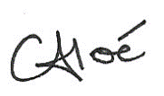
Céline Aloé
Group CEO

Resources:
- Keeping Children Safe in Education (September 2024) - Keeping children safe in education - GOV.UK (www.gov.uk)
- Working Together to Safeguard Children (December 2023 – edited February 2024) - Working together to safeguard children - GOV.UK (www.gov.uk)
- After-school clubs, community activities and tuition guidance (formerly Out of School Settings OOSS): After-school clubs, community activities and tuition: safeguarding guidance for providers - GOV.UK (www.gov.uk)
- Information Sharing (July 2018 – last updated May 2024) - Information sharing advice for safeguarding practitioners - GOV.UK (www.gov.uk)
- Sharing nudes and semi-nudes: advice for education settings working with children and young people - GOV.UK (www.gov.uk)
- Health and Safety: responsibilities and duties for schools
- Health protection in children and young people settings
- https://saferinternet.org.uk/

